# ANGELES UNIVERSITY FOUNDATIONauf logo blue colored-small.png

# *Angeles City*

**College of Computer Studies**

Center of Excellence in IT Education

**Salesforce Capstone**



Tours & Travels Platform Development Using CRM-Salesforce

Project Overview

This project aims to develop a CRM catering to the Tours and Travels company by using Salesforce’s long-list of world-class tools and my capabilities as a student who has gone through SmartBridge’s internship program. Providing solutions that include automated booking confirmations, cancellation approval processes, customer tracking, and guided travel packages

Objectives

The primary objective of the Travels and Tours project is to create an efficient and scalable CRM to manage end to end customer relations, from customers’ initial inquiry up to the final payment. The system was designed to improve customer data organization, automate booking processes, and automate follow-ups such as payment confirmations and booking cancellations. Also digitalizing manual tasks like guest tracking, approvals, and booking validations.

Phase 1: Requirements Analysis & Planning

**Understanding Business Requirements:**

The client needed a centralized platform that enables them to manage customer information, efficiently manage travel bookings, track payments and for the system to support internal workflows such as approvals and guest management. The manual processes previously were prone to errors and lacked real-time visibility. The CRM solution was formulated to be able to solve issues such as duplicated customer data, delayed booking approvals, unstructured follow-ups, and inconsistent communication between employees-to-employees as well as employees-to-customer relations.

**Defining Project Scope and Objectives:**

* Develop a Salesforce-based CRM tailor-fitted to the Tours and Travels operations.
* Centralize customer records that include validation and prevent duplicates.
* Automate booking payment tracking and confirmation workflows.
* Enable booking cancellations through an approval process.
* Establish role-based data access for travel agents, managers and admins.
* Provide reporting tools for sales and operational insights.

**Designing Data Model and Security Model:**

* **Objects Created:** Customer Info, Travel Package, Booking, Booking Guest, Booking Payment, Employee
* **Relationships:** Lookup relationships between Booking and Customer Info, Travel Package, and Employees.
* **Security:** Role hierarchy and profiles are established. Field-level security ensures sensitive data such as emails, and payment details are only visible to applicable users.

**Creating Project Roadmap & Milestones:**

* Phases are broken down into deliverables such as creating objects, validation rules, automation by creating flows/triggers, page layouts, testing and data import.
* Follow milestones set indicated in each phase.
* Utilize Skillwallet’s provided ‘Workspace’ and ‘Kanban’ features.

Phase 2: Salesforce Development –Backend & Configurations

## **Milestone 1: Salesforce Account**

### *Activity 1: Creating Developer Account*

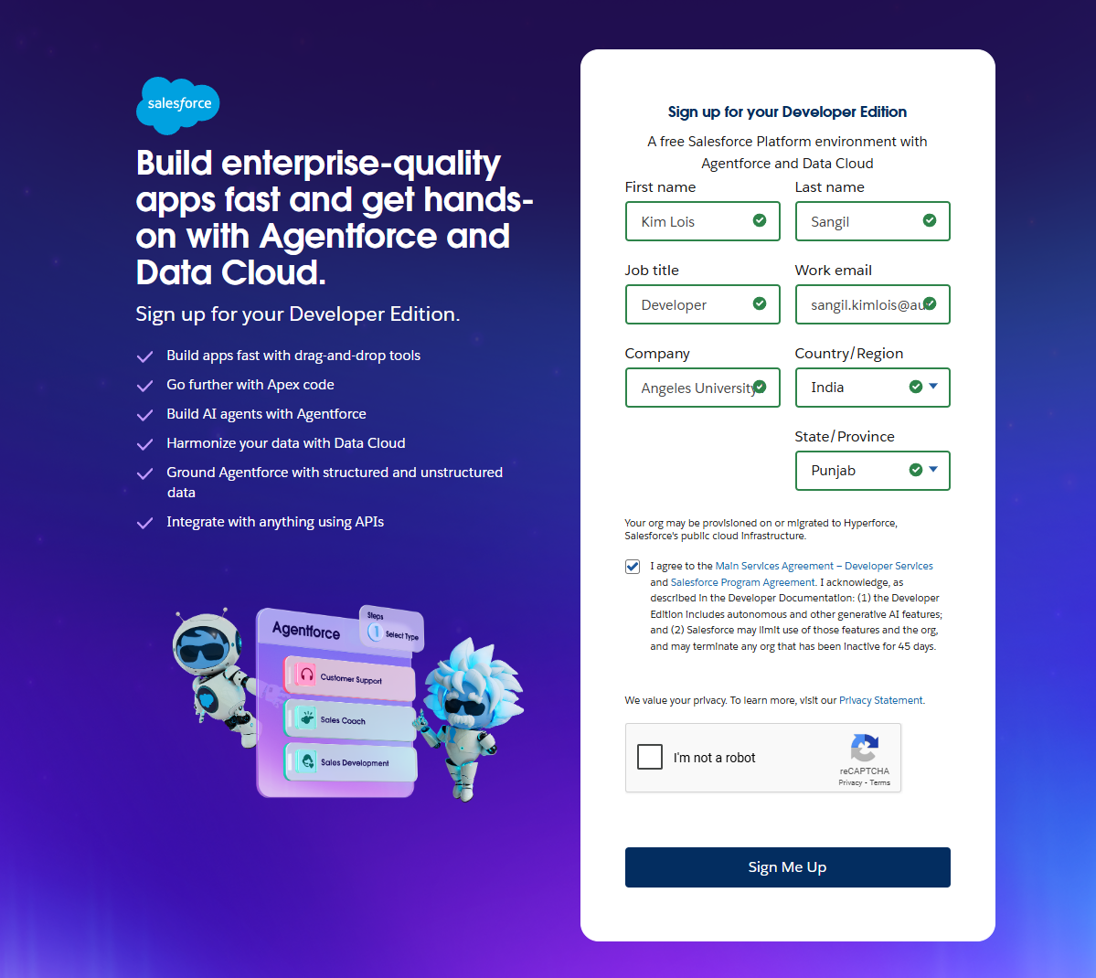

### *Activity 2: Account Activation*

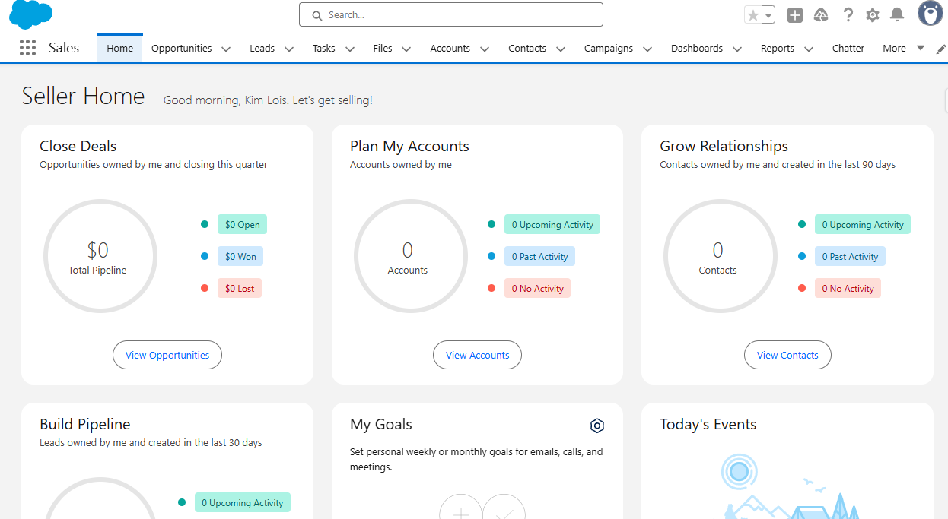

## **Milestone 2: Objects Creation**

### *Activity 1: Creating a Customer Info Object*

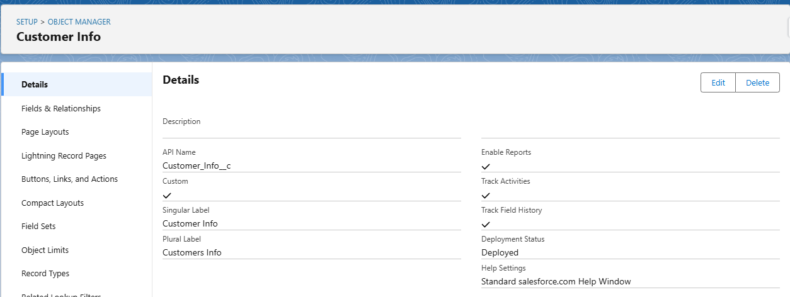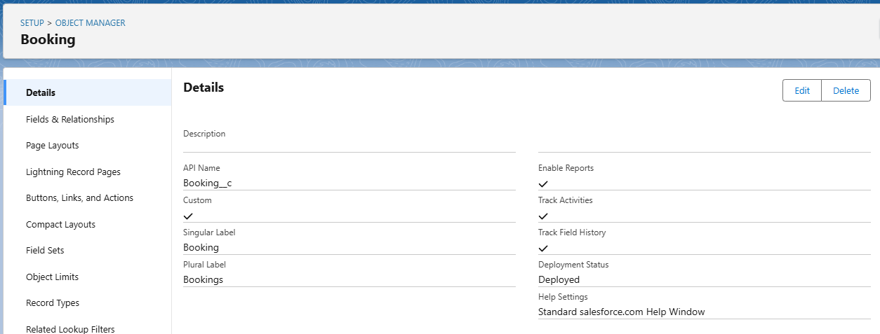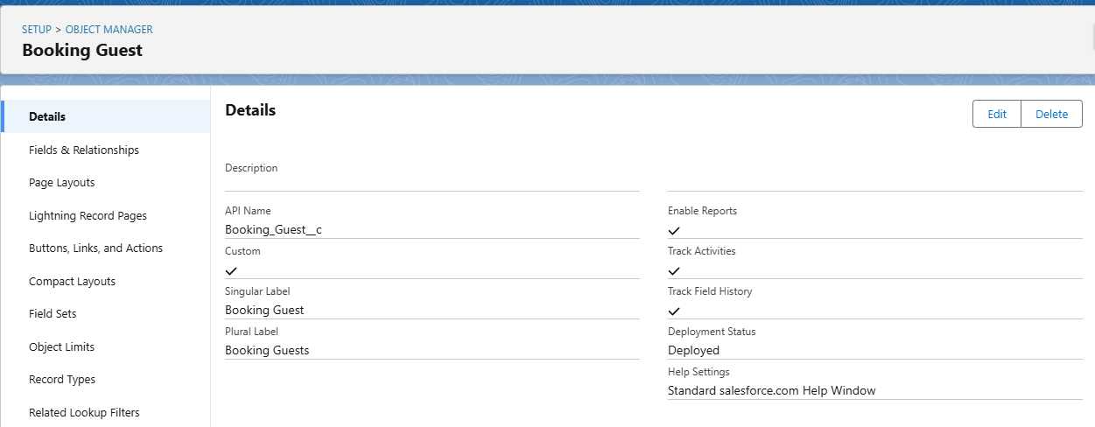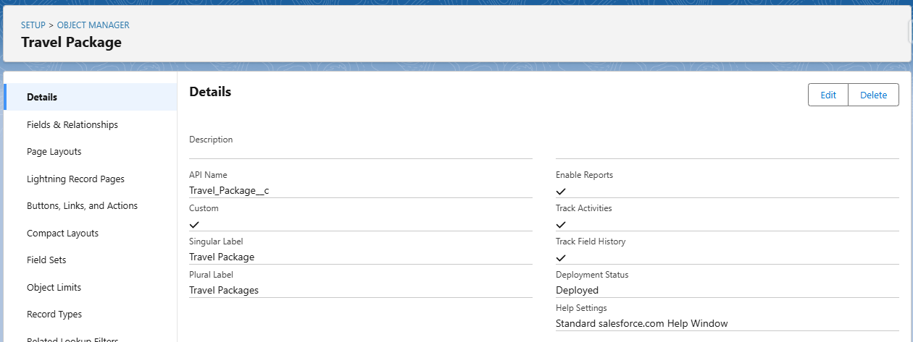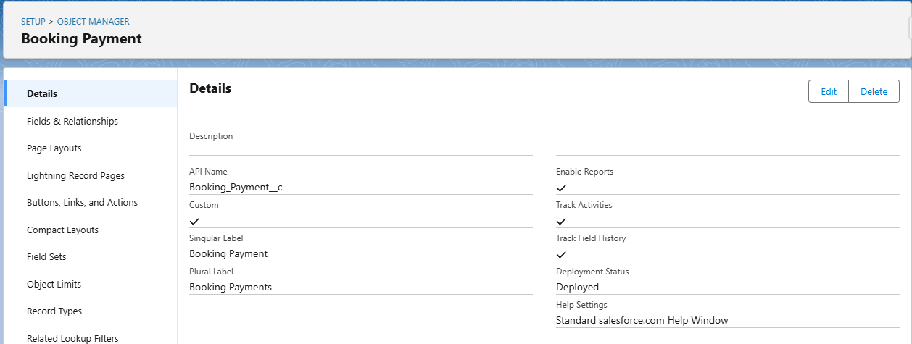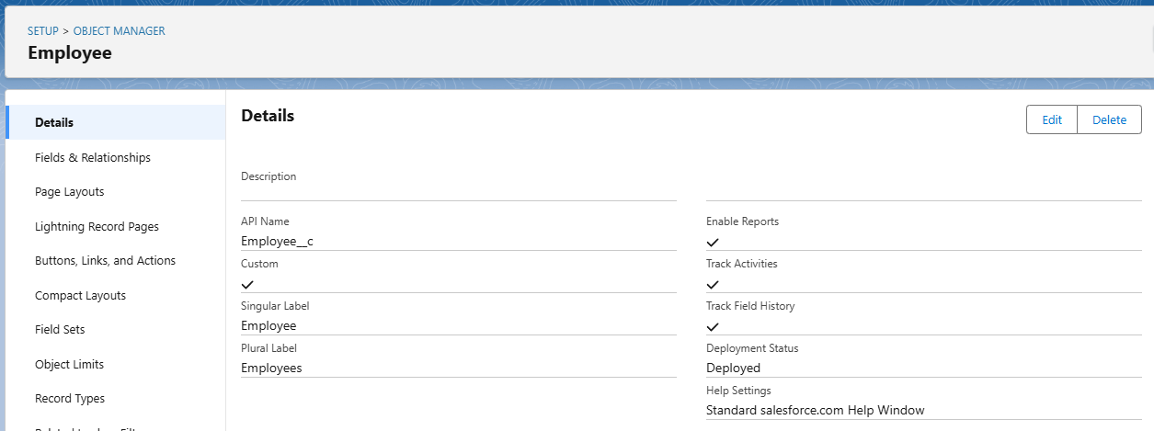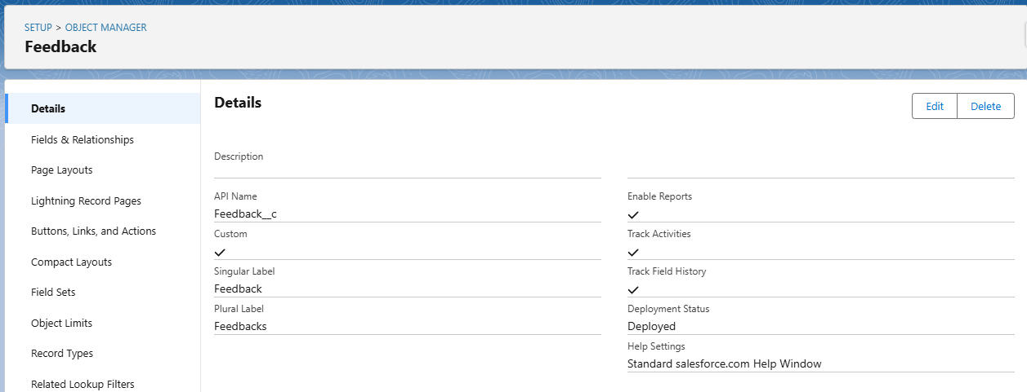

## **Milestone 3: Objects Creation**

### *Activity 1: Creating a tab for Customer Info Object*

### *Activity 2: Creating Remaining Tabs*

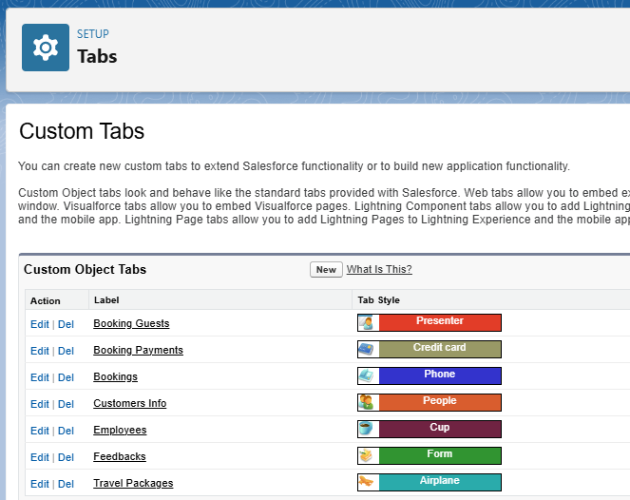

## **Milestone 4: Fields & Relationships**

### *Activity 1: Creation of fields for the Customer Info Object*

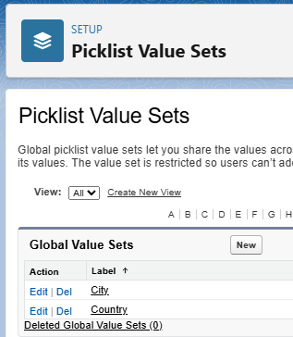

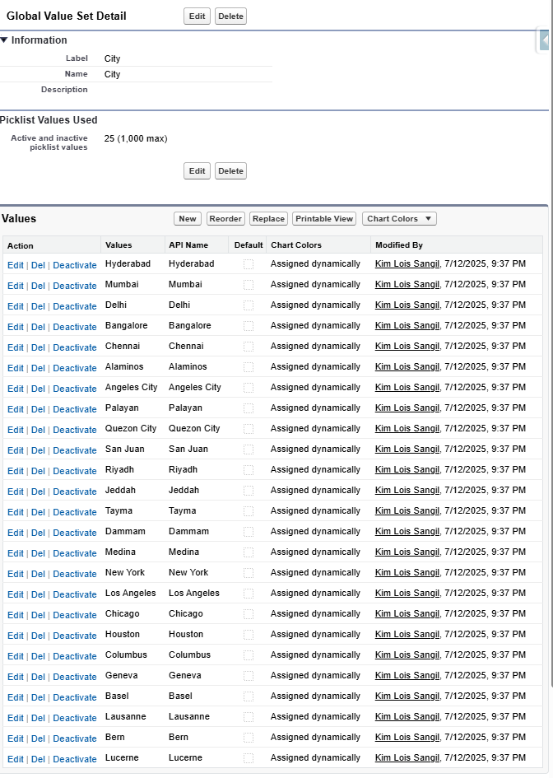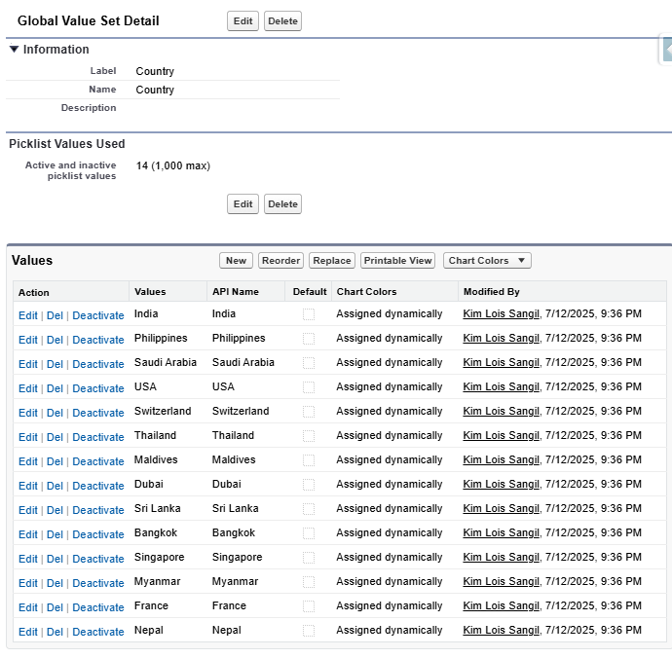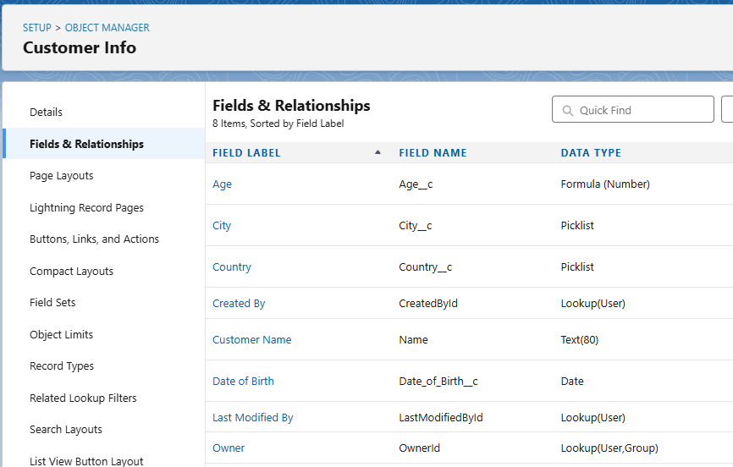

### *Activity 2: Creating Lookup Relationship in Booking Object*

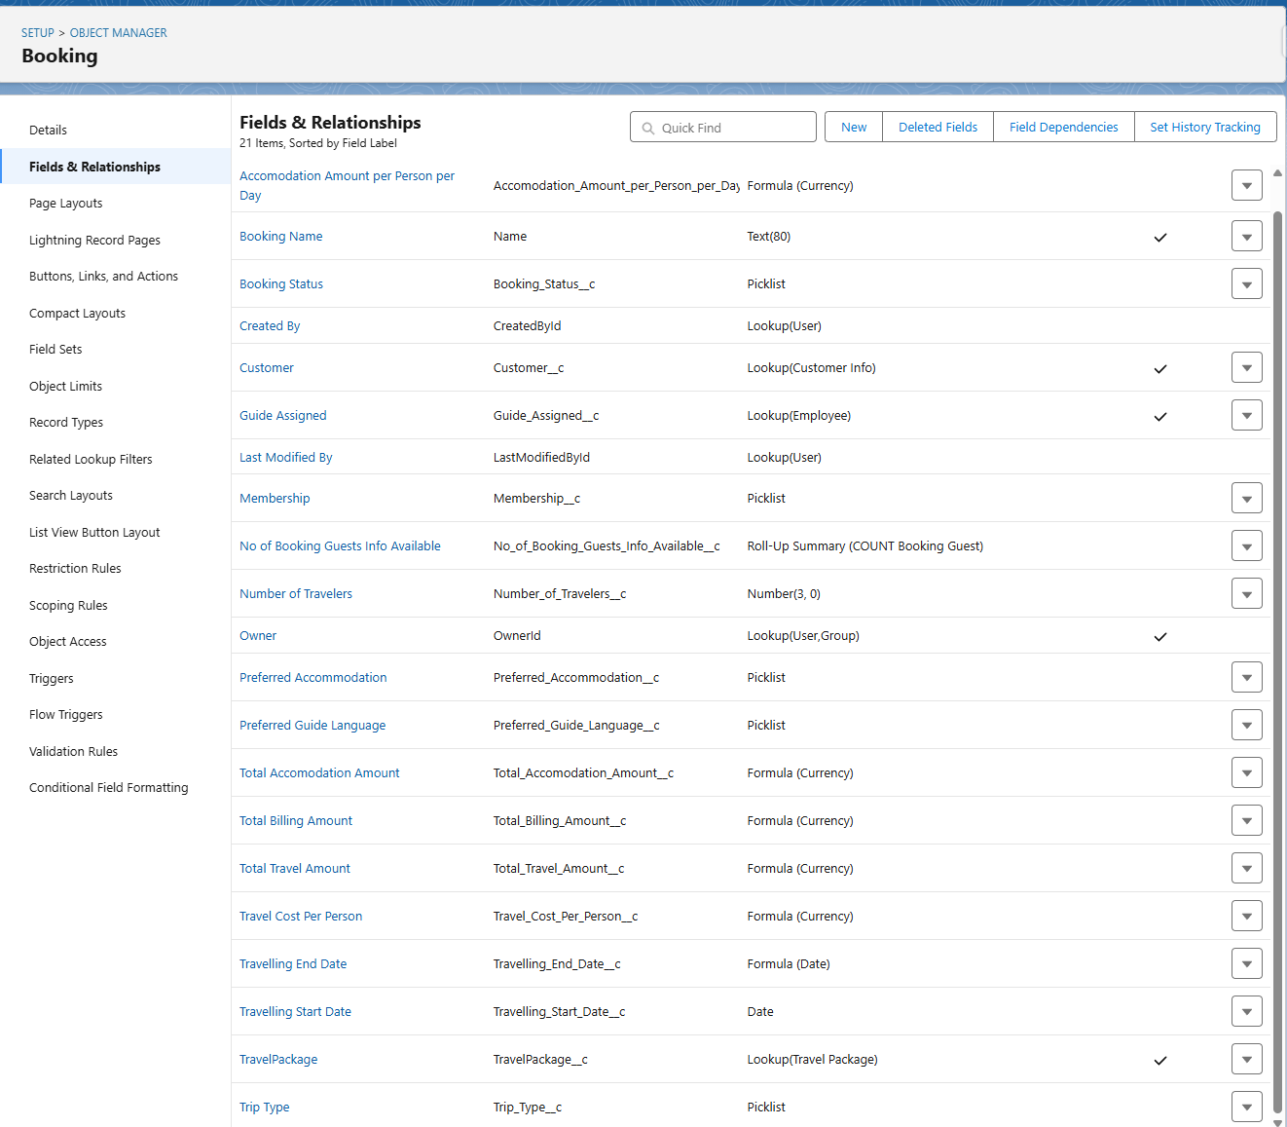

### *Activity 3: Creation of fields for the Booking Guest Object*

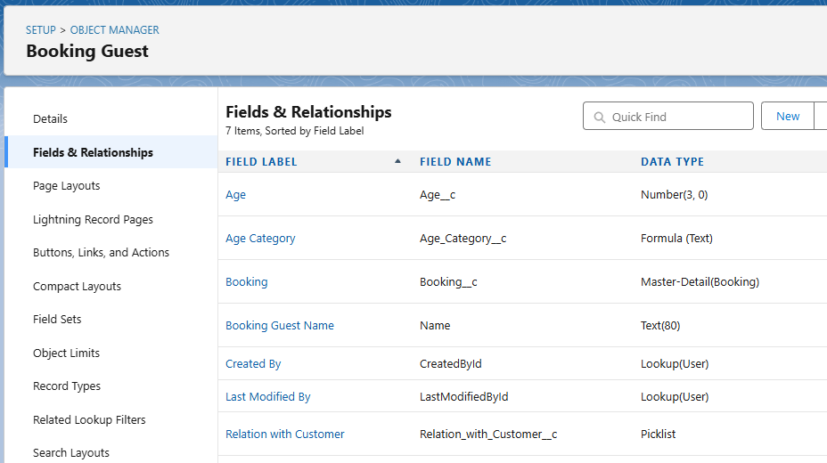

### *Activity 4: Creation of fields for the TravelPackage Object*

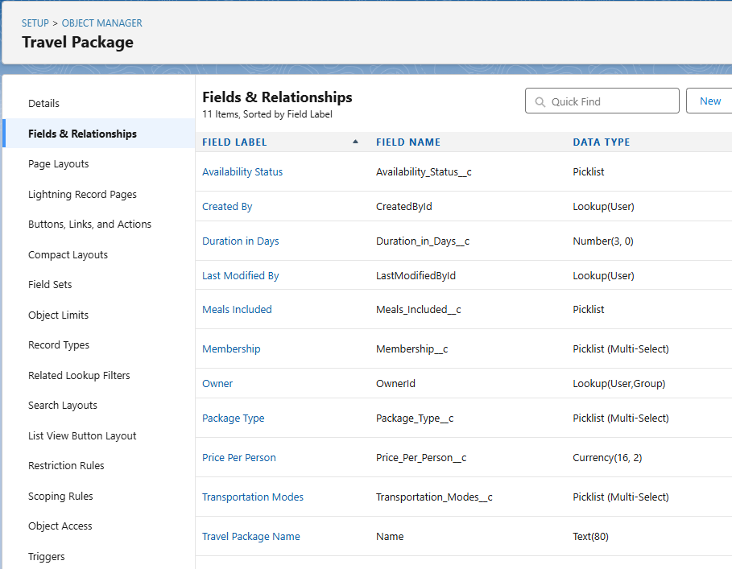

### *Activity 5: Creation of fields for the Employee Object*

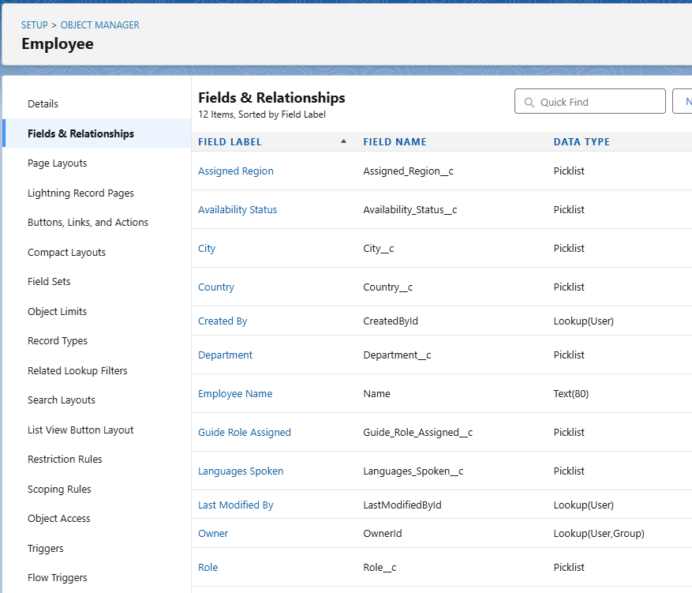

### *Activity 6: Creation of fields for the Booking Payment Object*

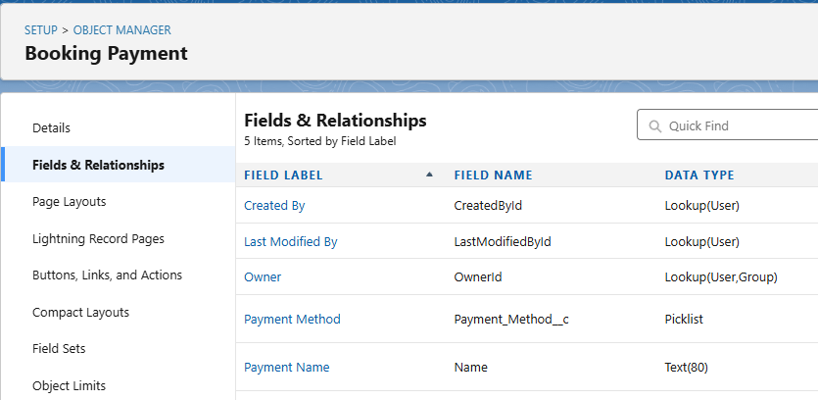

## **Milestone 5: Field Dependencies**

### *Activity 1: Creating a Field Dependency in BookingGuest Object*

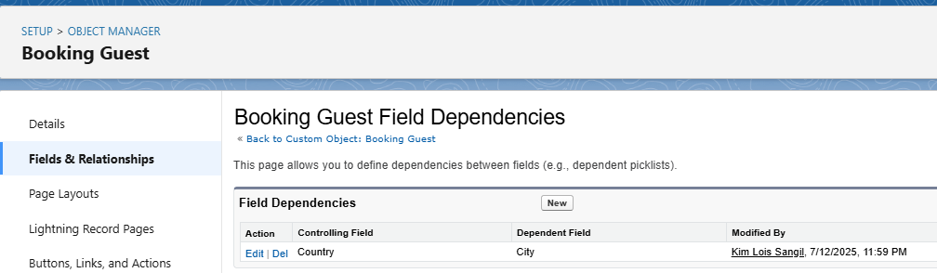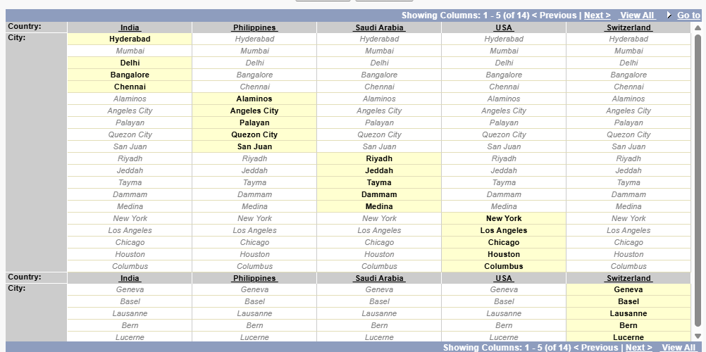

### *Activity 2: Creating a Field Dependency in Booking Object*

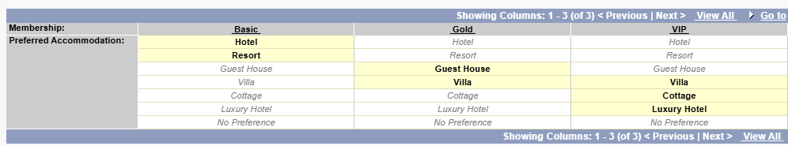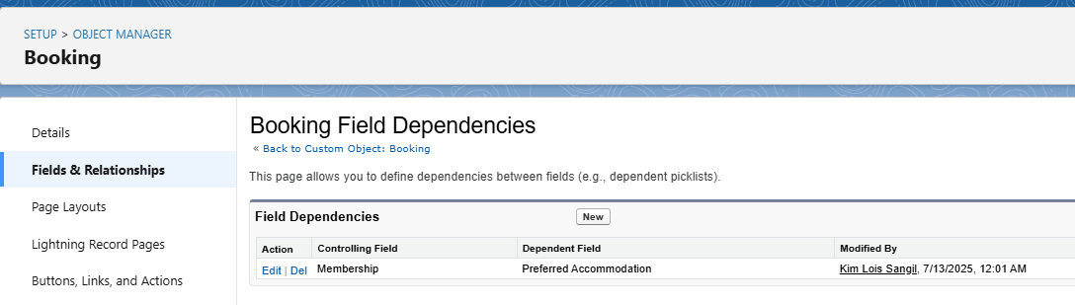

### *Activity 3: Creating a Field Dependency in Employee Object*

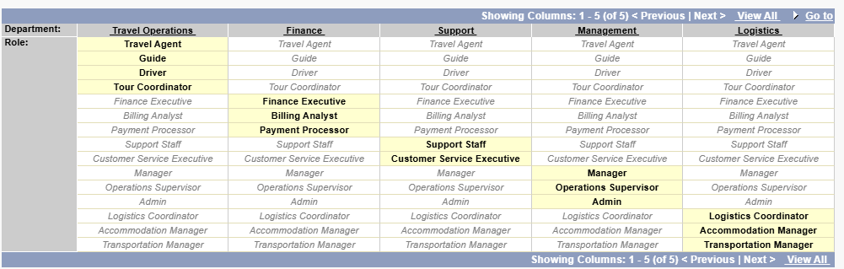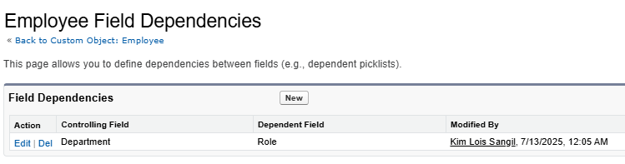

### *Activity 4: Creating another Field Dependency in Employee Object*

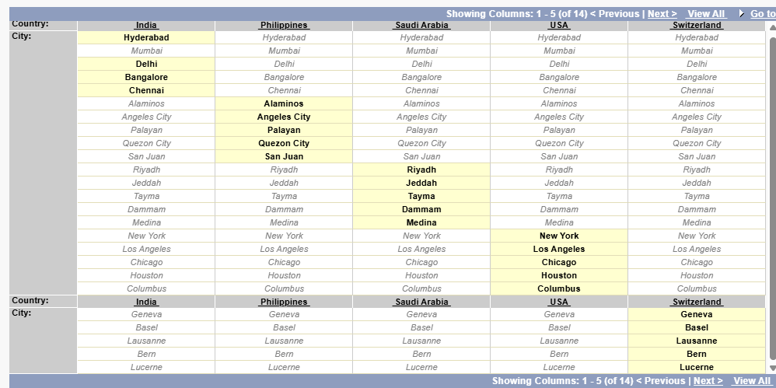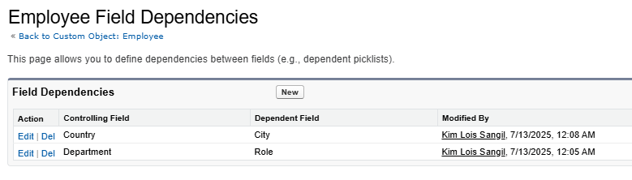

## **Milestone 6: Validation Rules**

### *Activity 1: To create validation rules to a Customer Info Object*

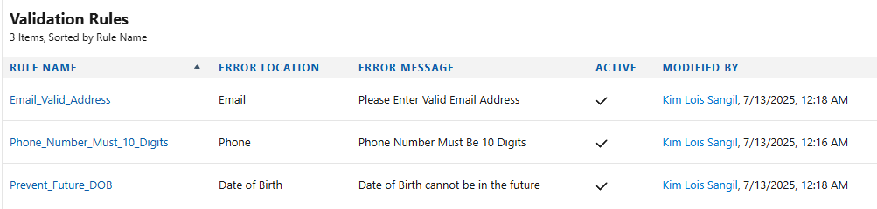

### *Activity 2: To create validation rules to a BookingGuest Object*

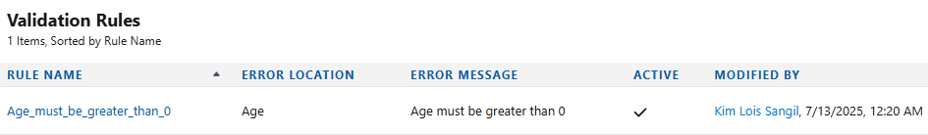

### *Activity 3: To create validation rules to a Employee Object*

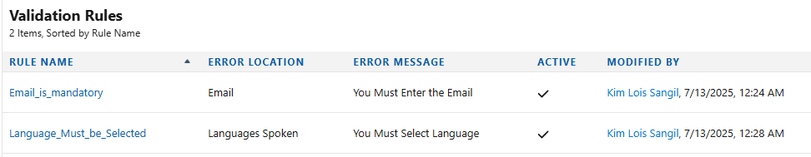

### *Activity 4: To create validation rules to a Booking Object*

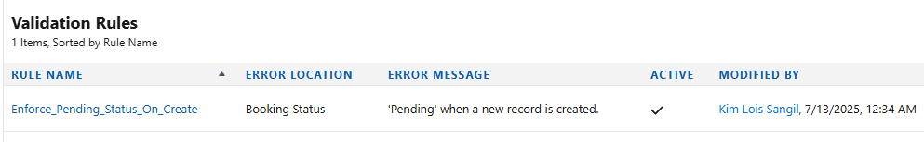

## **Milestone 7: Approval Process**

### *Activity 1: Create an approval process for Booking Cancellation Approval*

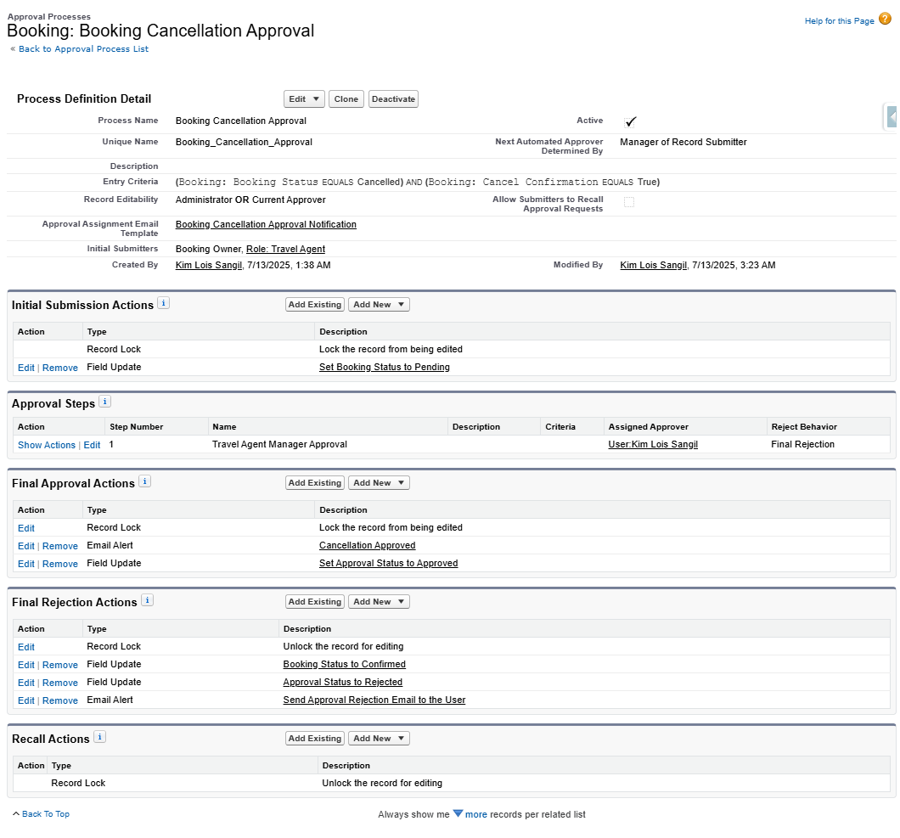

## **Milestone 8: Flows**

### *Activity 1: Create a Flow to ensure that the number of BookingGuest records does not exceed the number of Travellers specified in the related Booking record,if exceeds Popup an error to prevent saving*

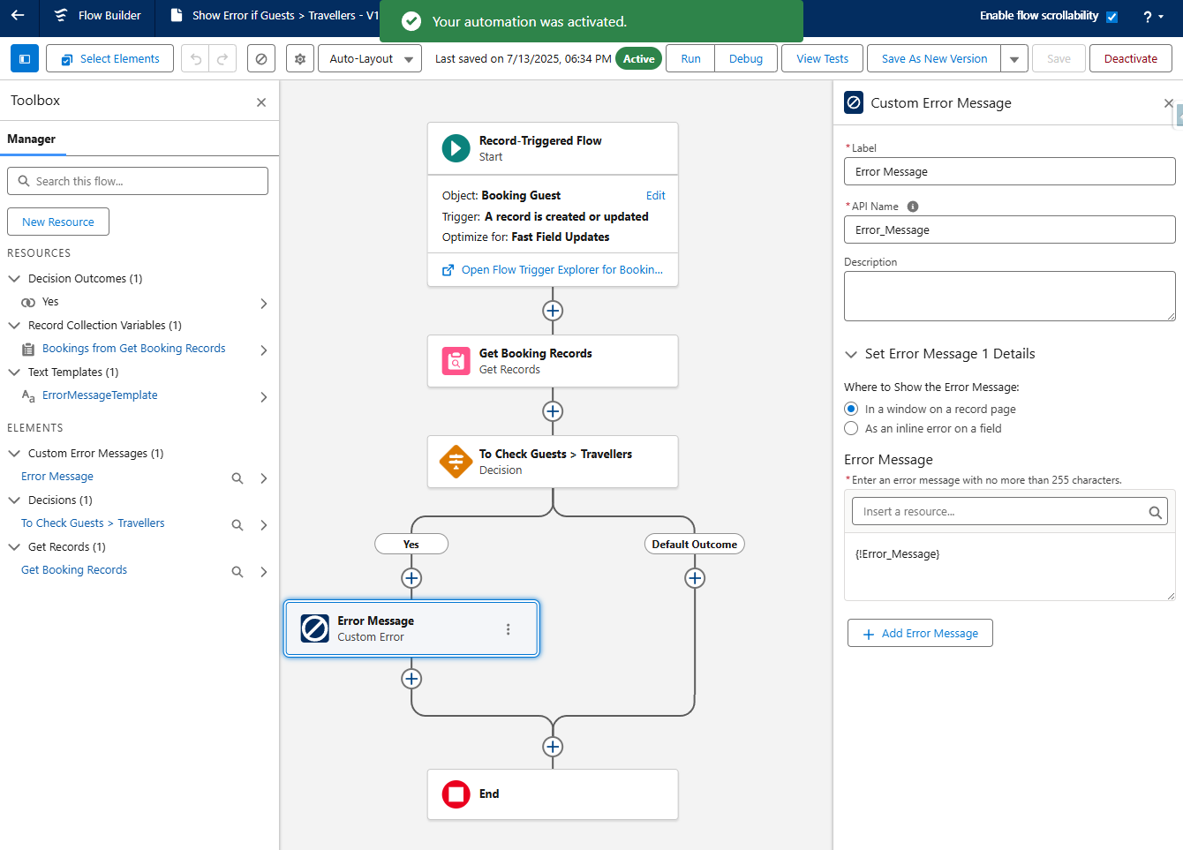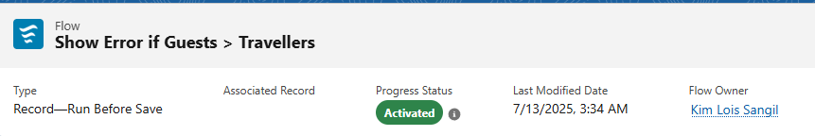

## **Milestone 9: Workflows**

### *Activity 1: Automatically create a Task for the Travel Agent to follow up with the customer for feedback, Due date is 3 days after the Travelling End Date, whenever a booking is marked as Completed*

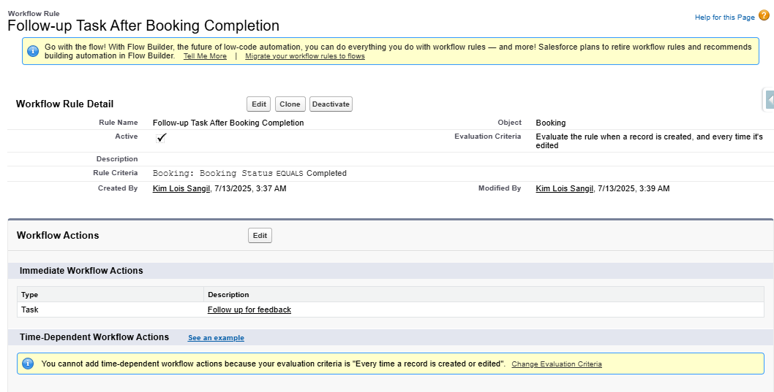

## **Milestone 10: Process Builder**

### *Activity 1: The Tours and Travels CRM application manages bookings and payments for various tour packages worldwide. To streamline operations and reduce manual intervention, the business wants to automatically update the Booking status to “Confirmed” once the payment is successfully completed*

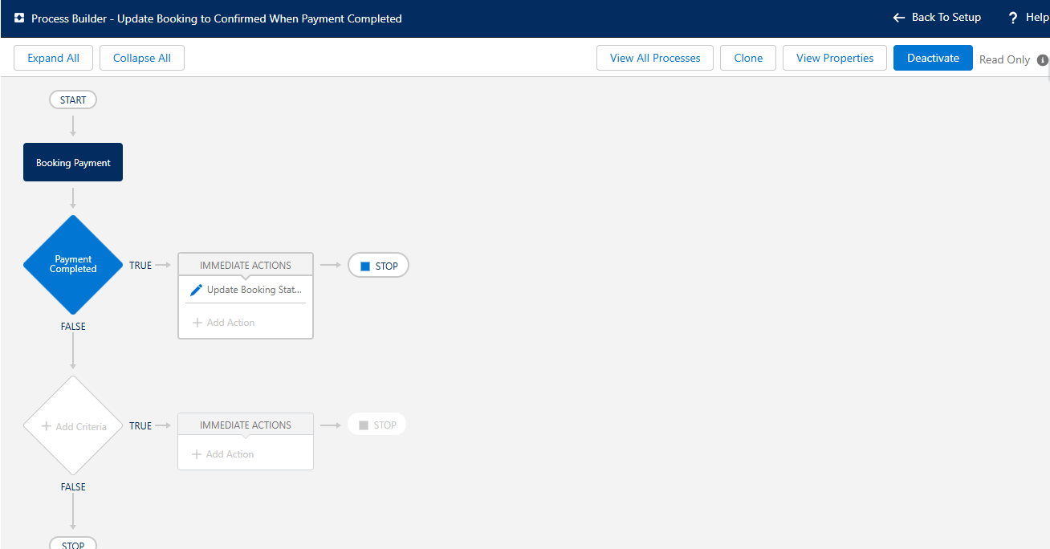

## **Milestone 11: Triggers**

### *Activity 1: Auto-create Booking Payment Method*

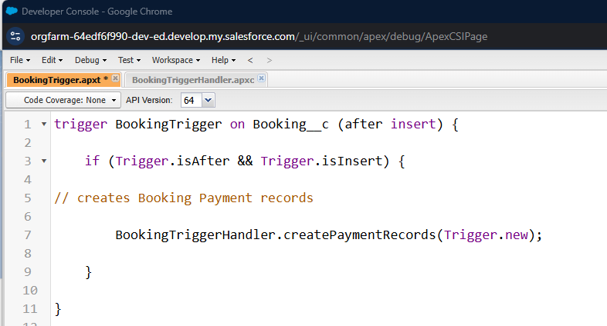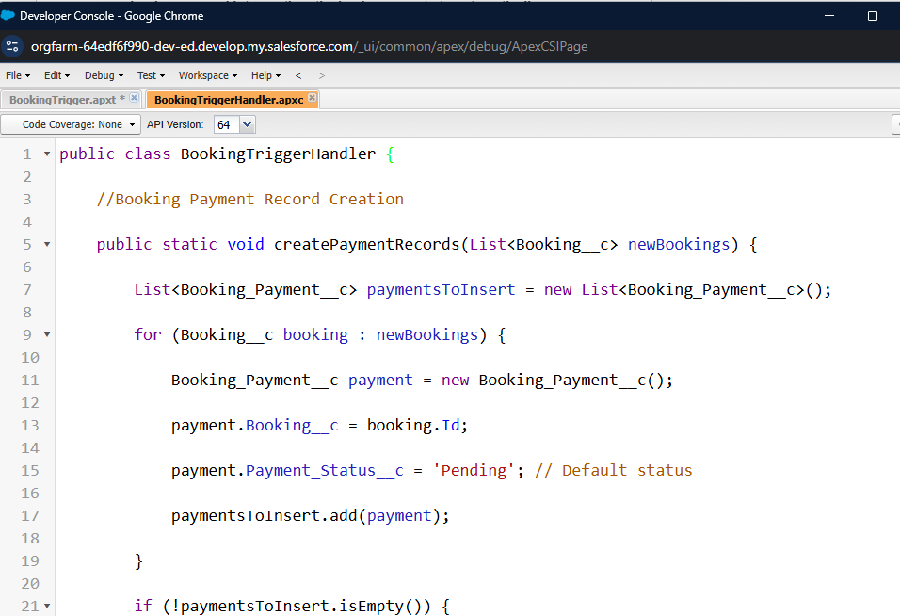

### *Activity 2: Automate Guest Records Creation Based on Traveller Count*

##### 

***Test Booking:***  
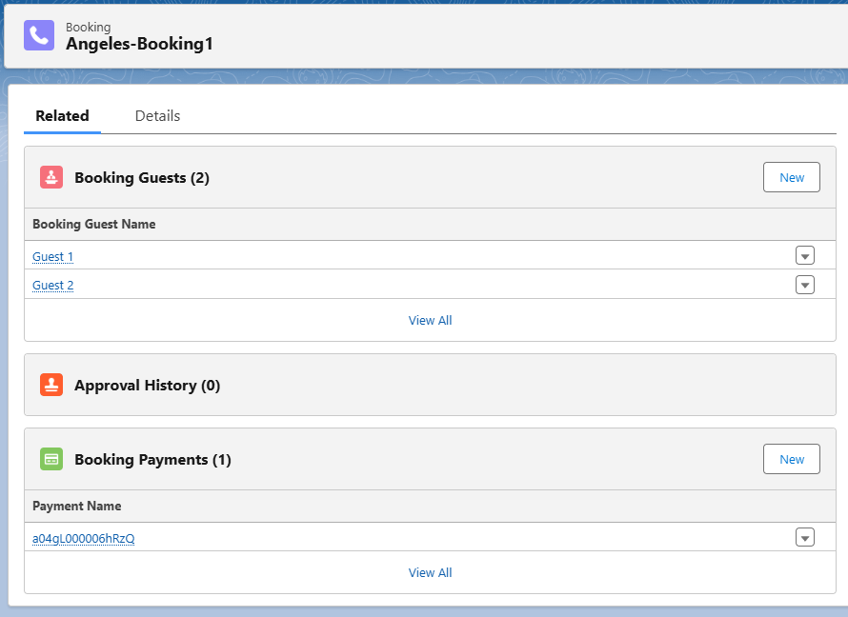

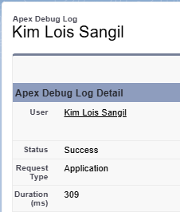

## **Milestone 12: Asynchronous Apex**

### *Activity 1: Future Asynchronous Apex*

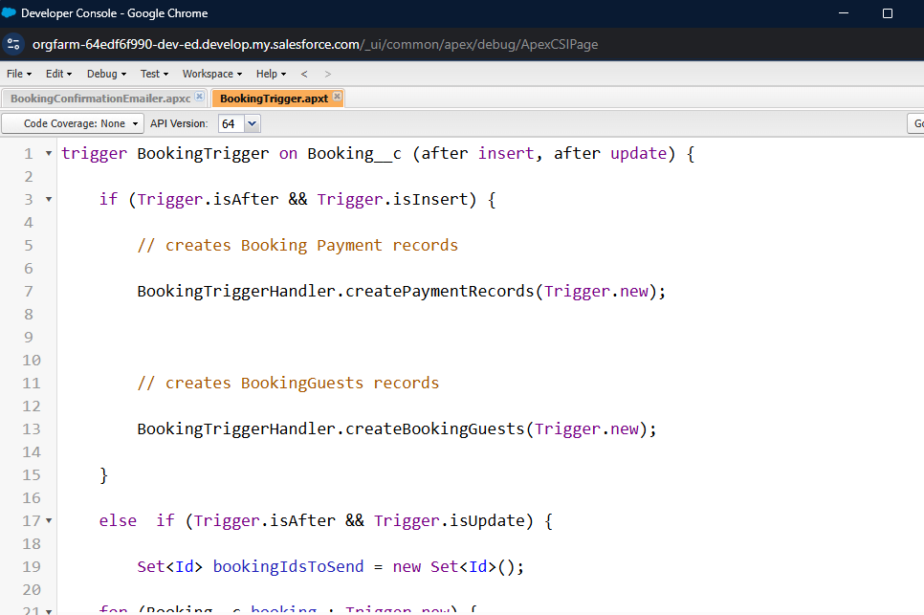

***Test Booking:***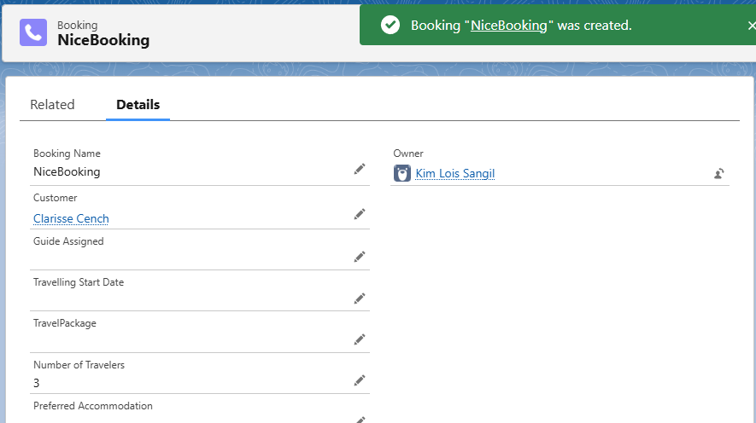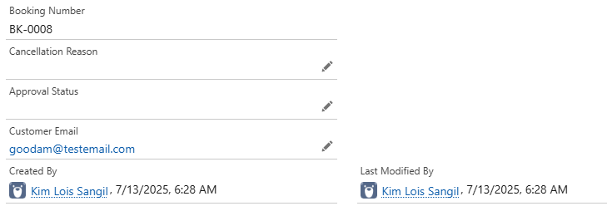

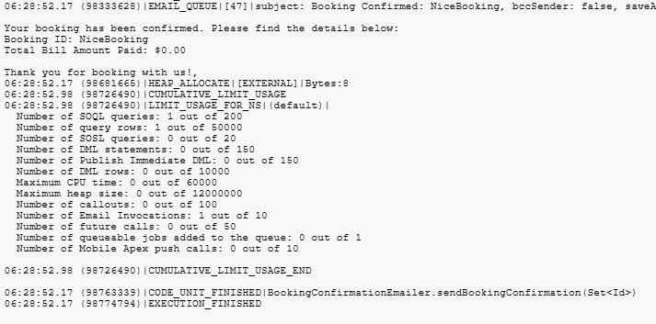

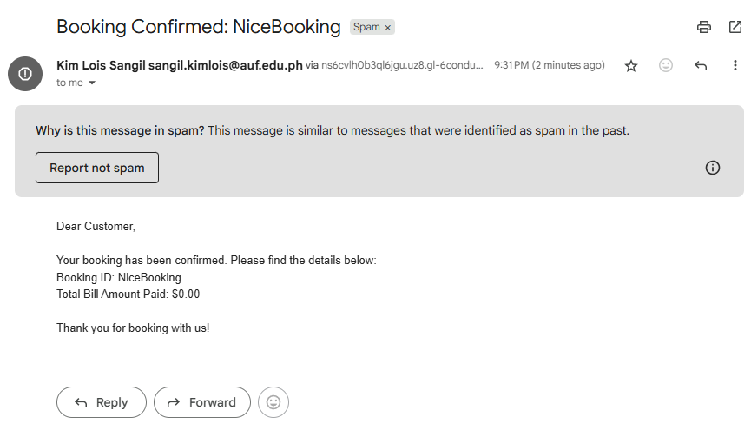

### *Activity 2: Queueable and Schedulable Asynchronous Apex*

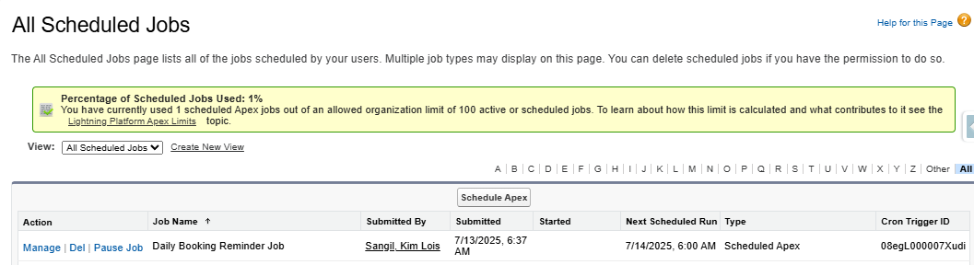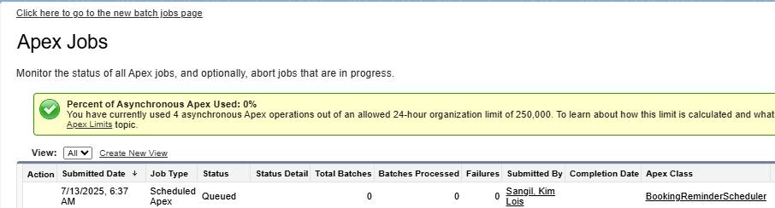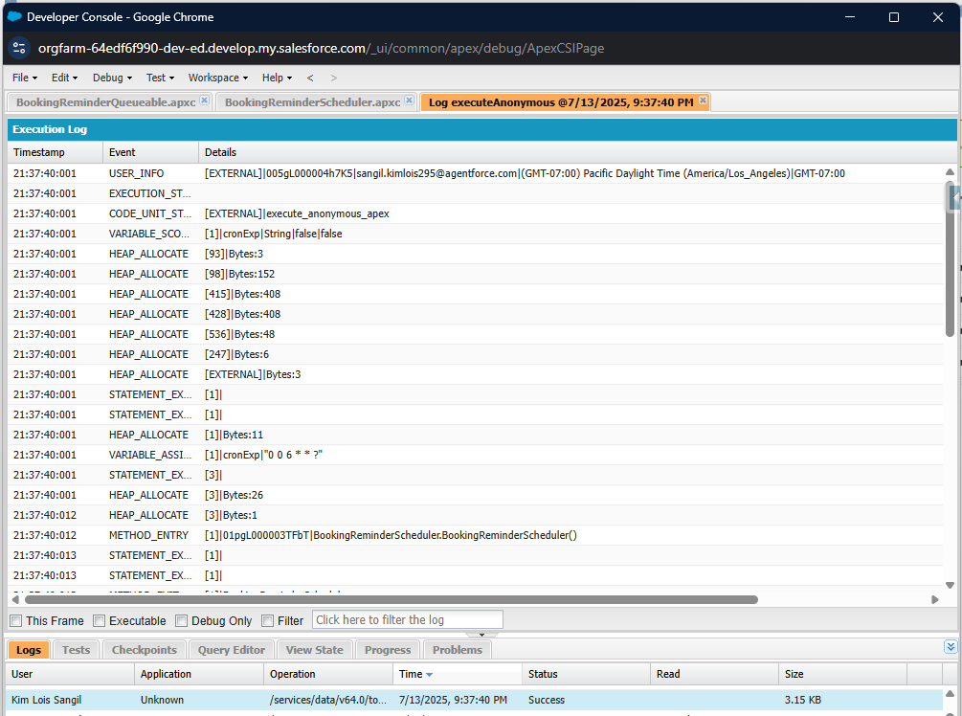

### *Activity 3: Batchable and Schedulable Asynchronous Apex*

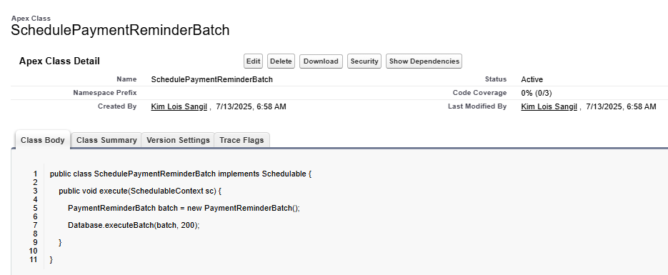

Phase 3: UI/UX Development & Customization

## **Milestone 13: The Lightning App**

### *Activity 1: Create a Lightning App for “Tours & Travels CRM”*

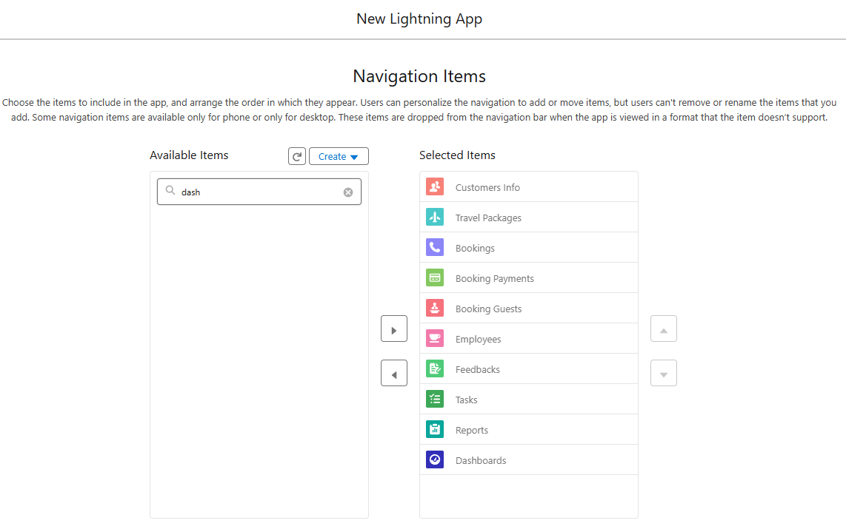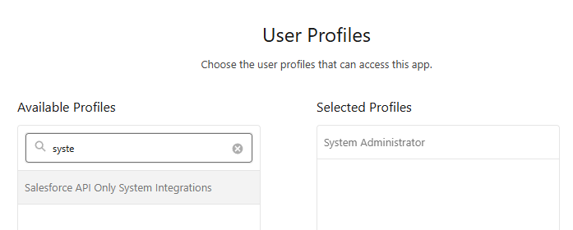

## **Milestone 14: Editing of Page Layouts**

### *Activity 1: To edit a Page Layout in Customer Info Object*

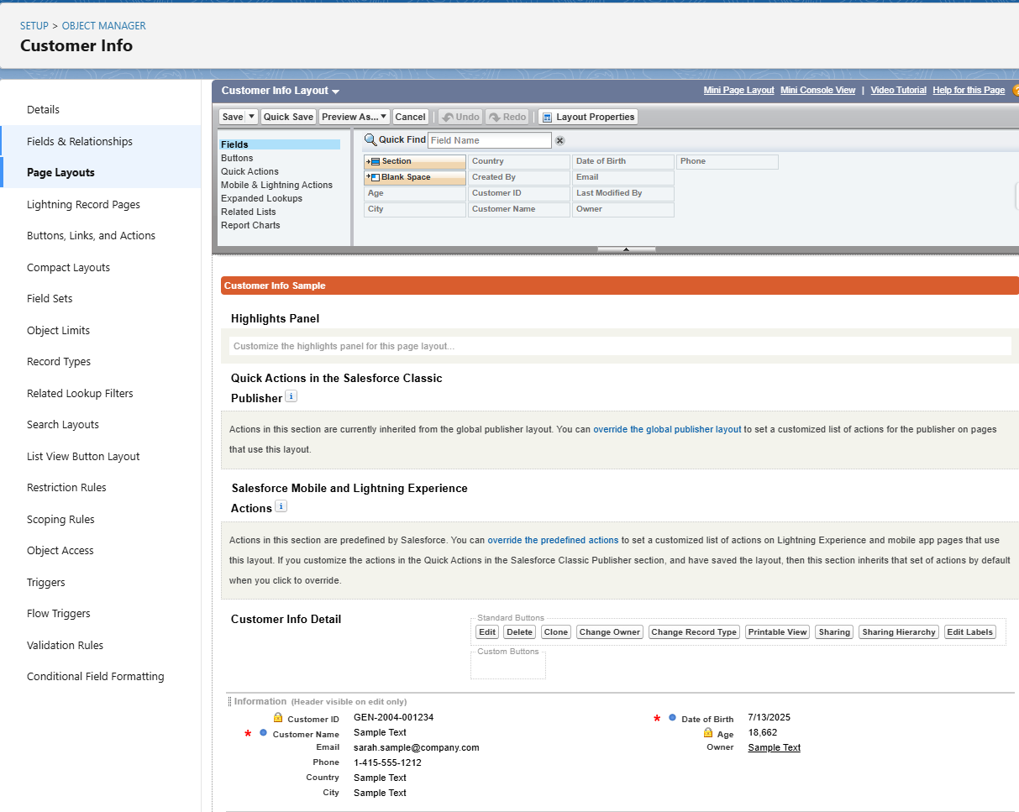

### *Activity 2: To edit a Page Layout in BookingGuest Object*

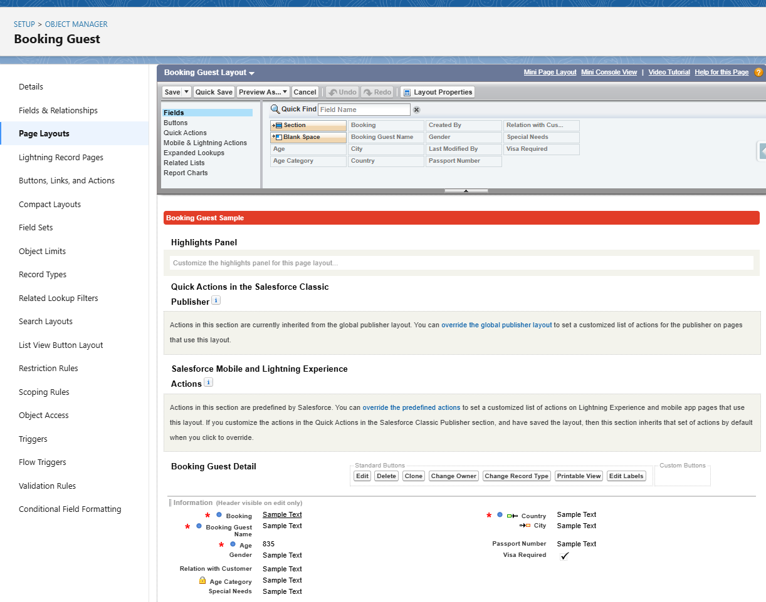

### *Activity 3: To edit a Page Layout in TravelPackage Object*

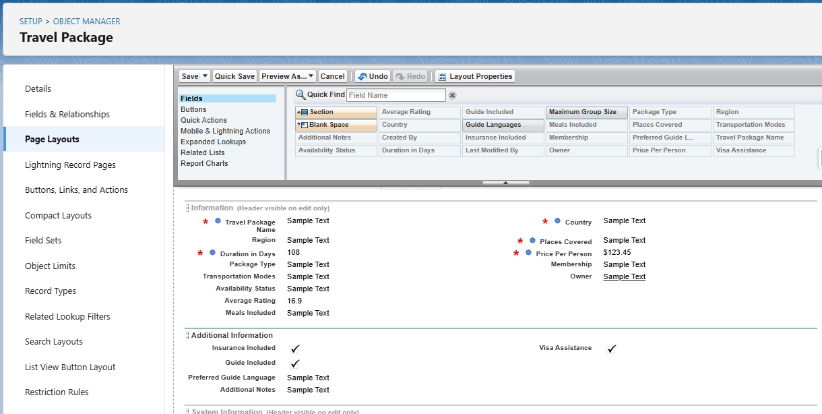

### *Activity 4: To edit a Page Layout in Employee Object*

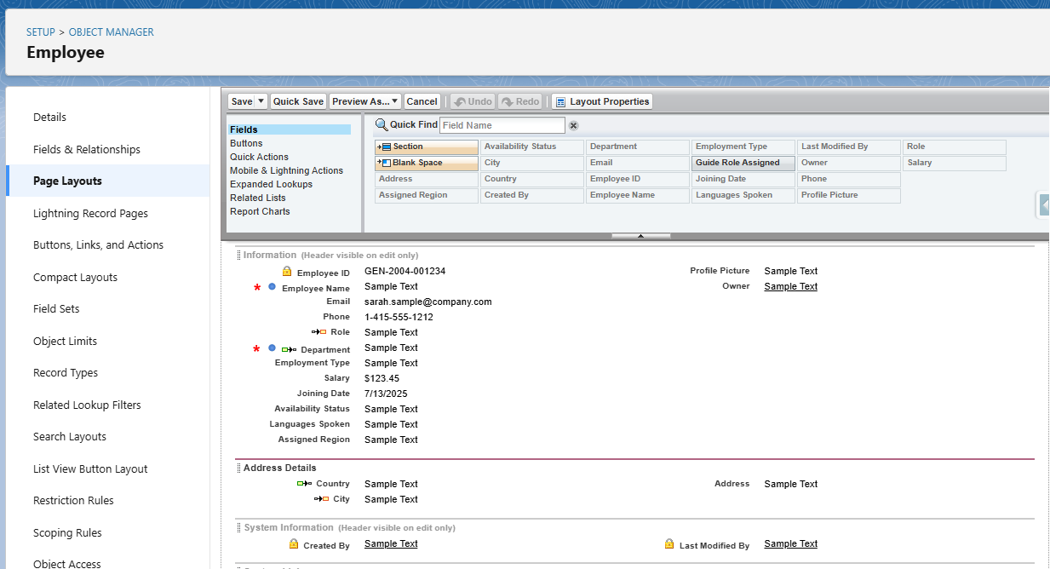

### *Activity 5: To edit a Page Layout in Booking Object*

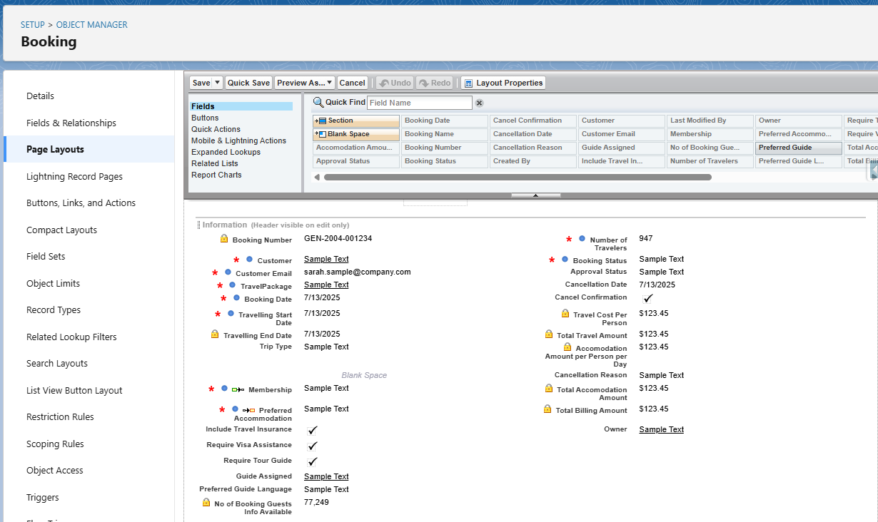

### *Activity 6: To edit a Page Layout in Booking Payments Object*

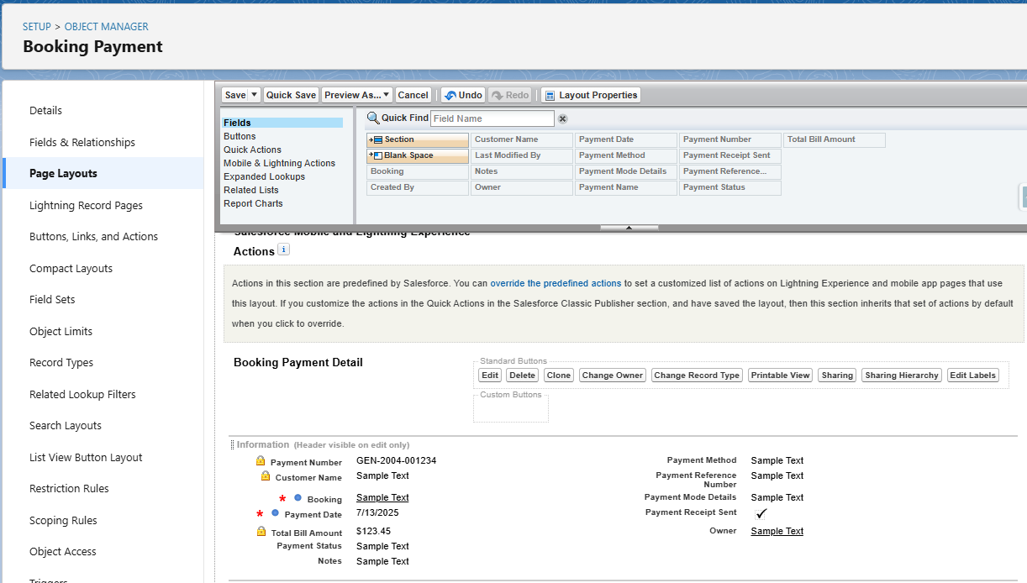

### *Activity 7: To edit a Page Layout in Feedbacks Object*

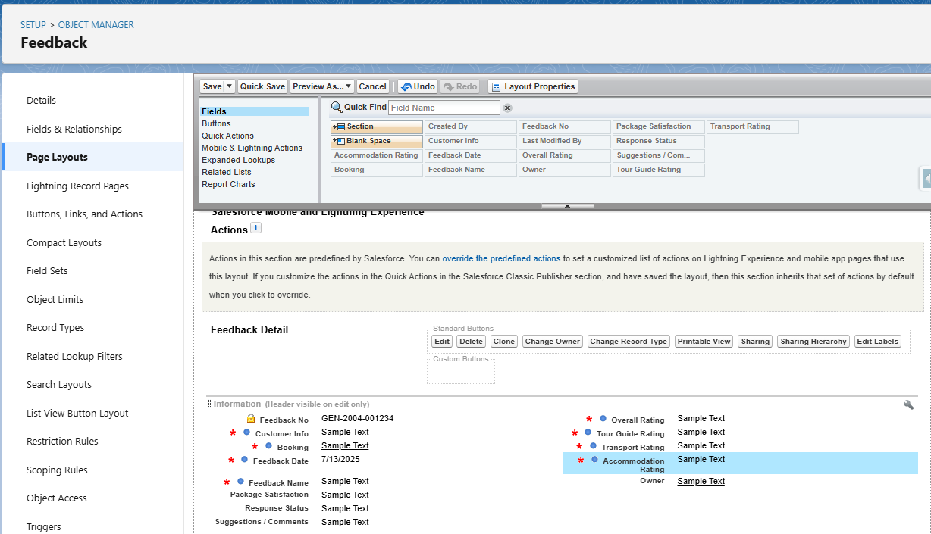

## **Milestone 15: Dynamic Forms**

### *Activity 1: To create a Dynamic Form in Booking Object*

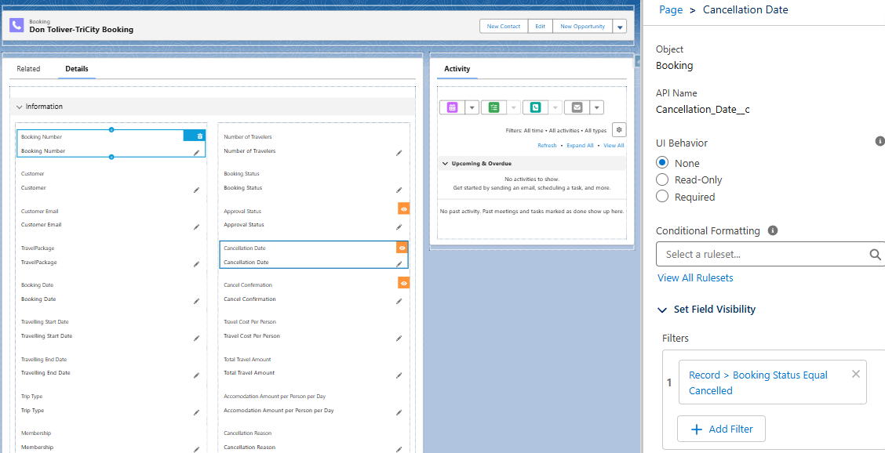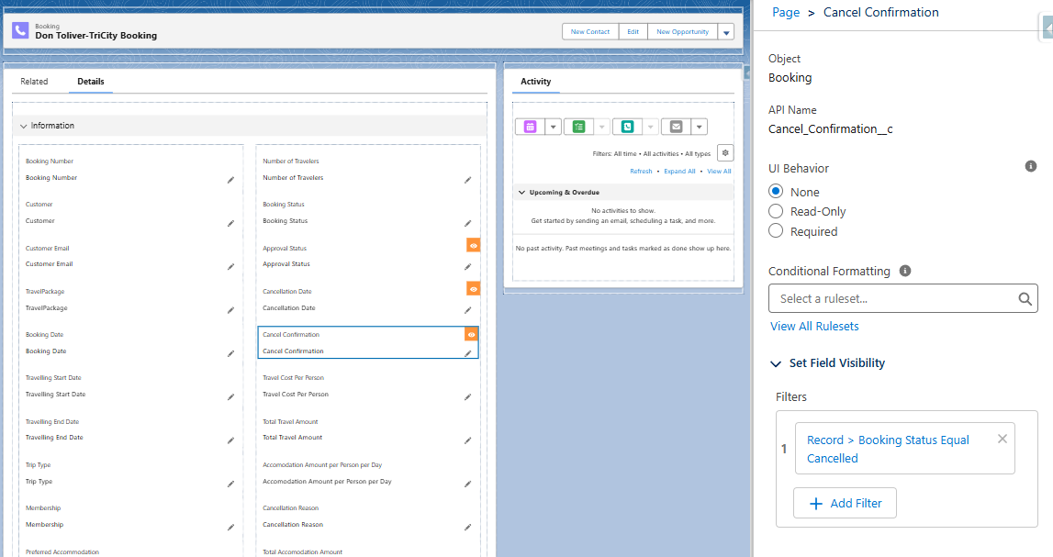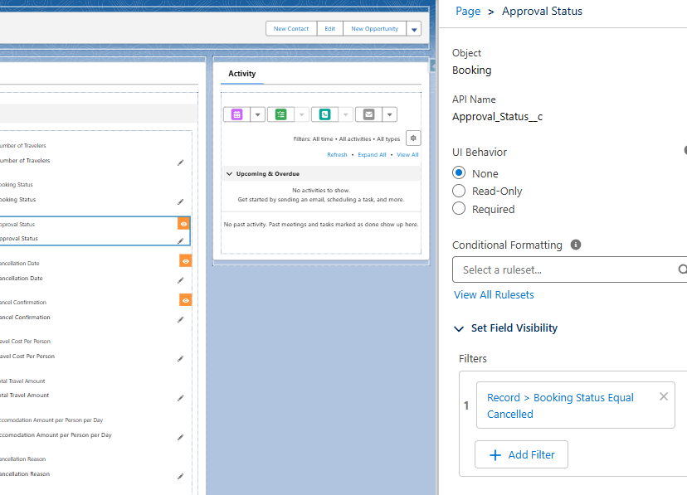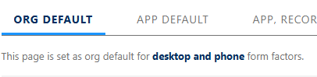

## **Milestone 16: Users**

### *Activity 1: Create User*

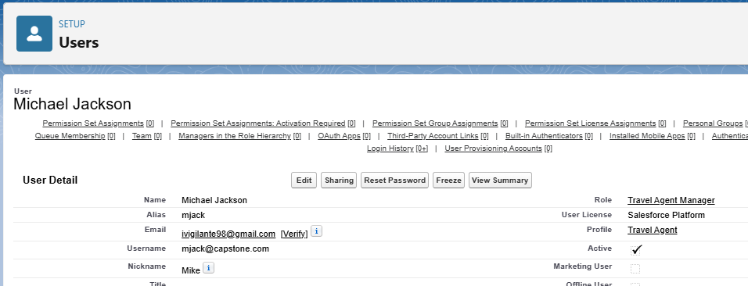

### *Activity 2: Creating other users*

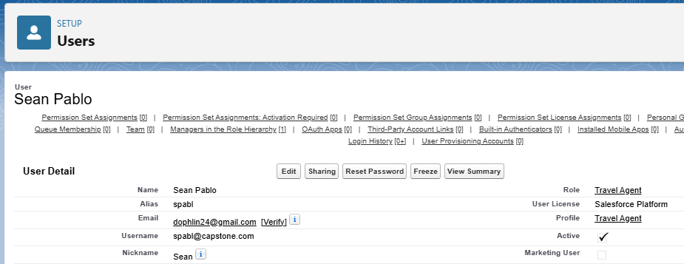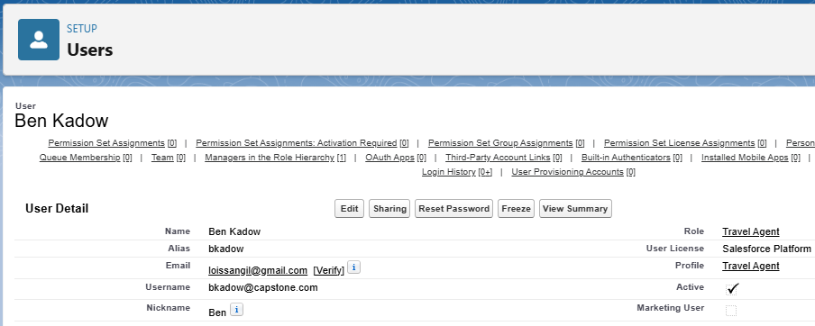

## **Milestone 17: Reports**

### *Activity 1: Create a Report Folder*

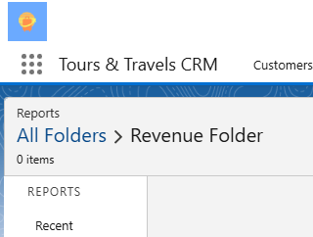

### *Activity 2: Sharing a Report Folder*

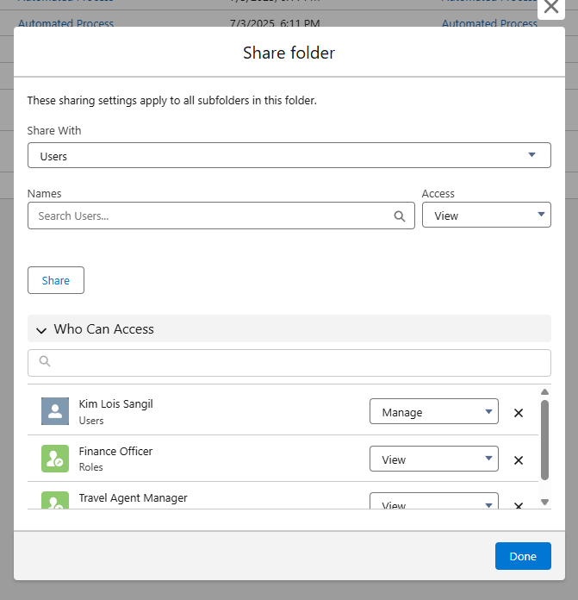

### *Activity 3: Create Report*

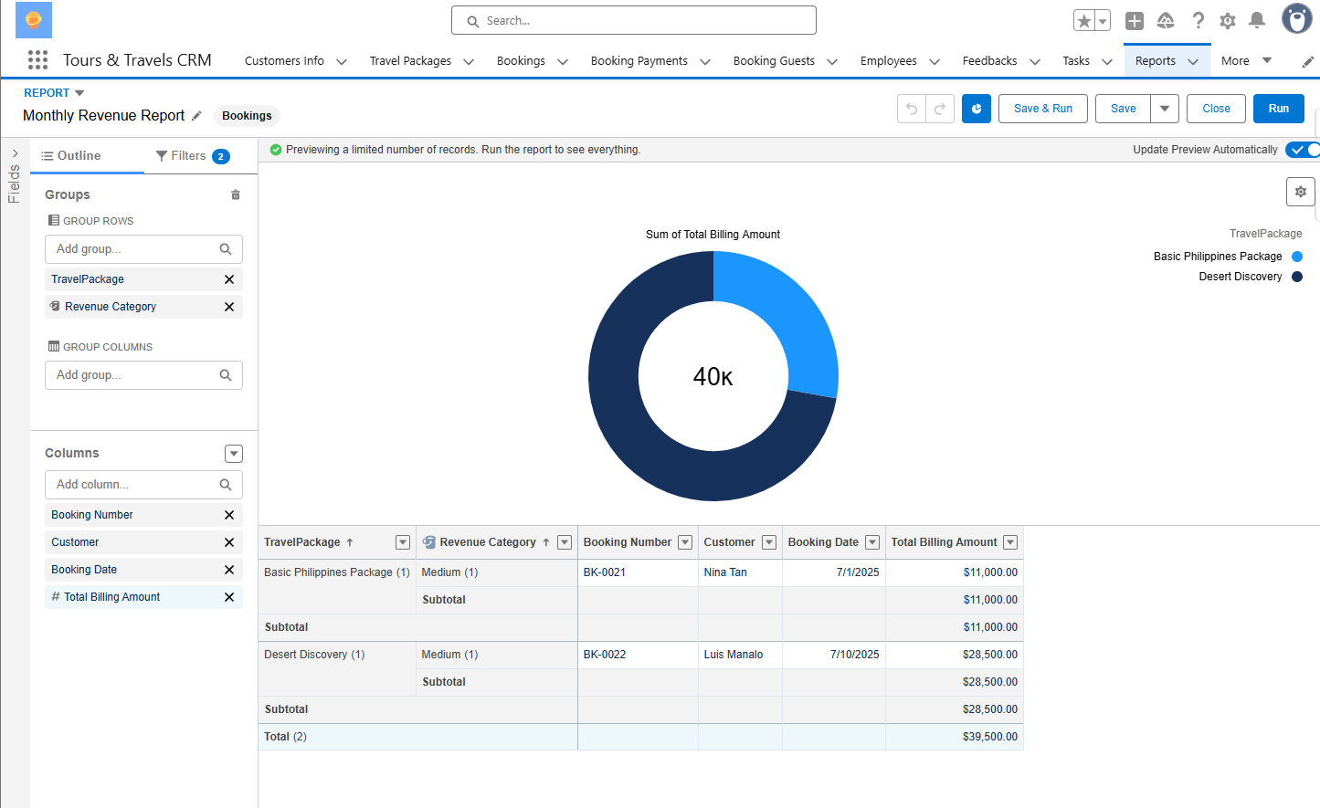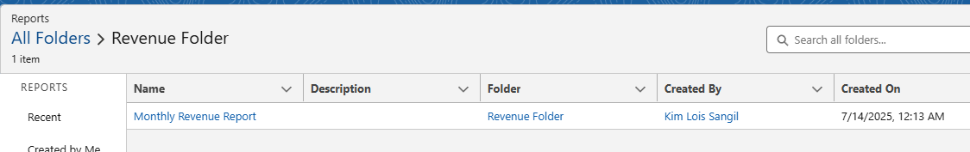

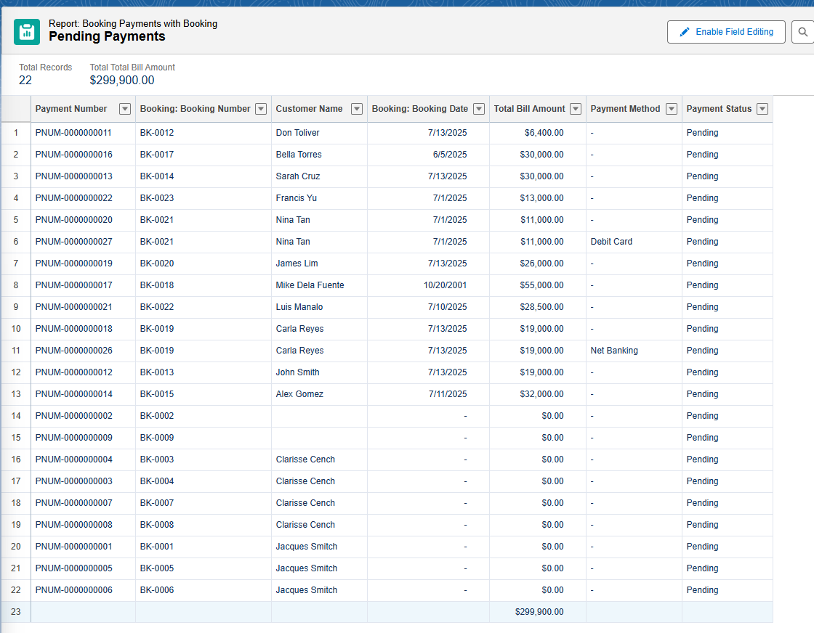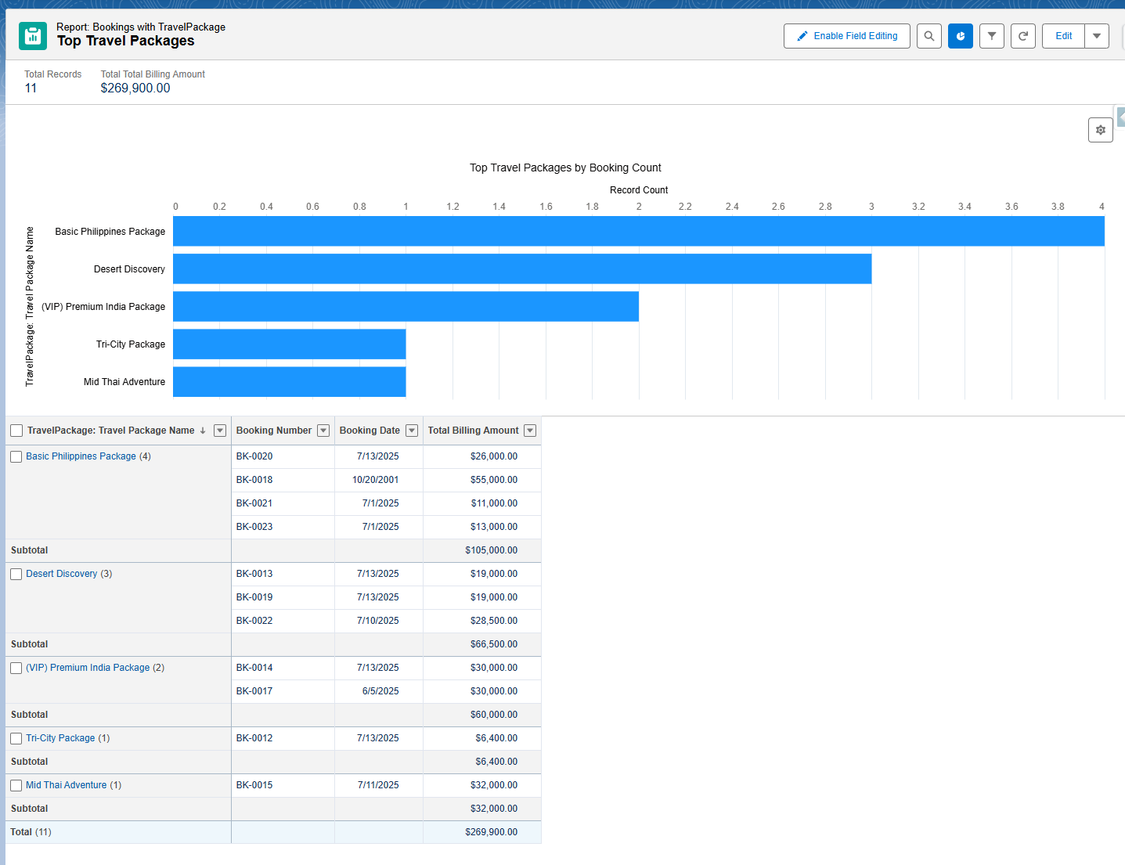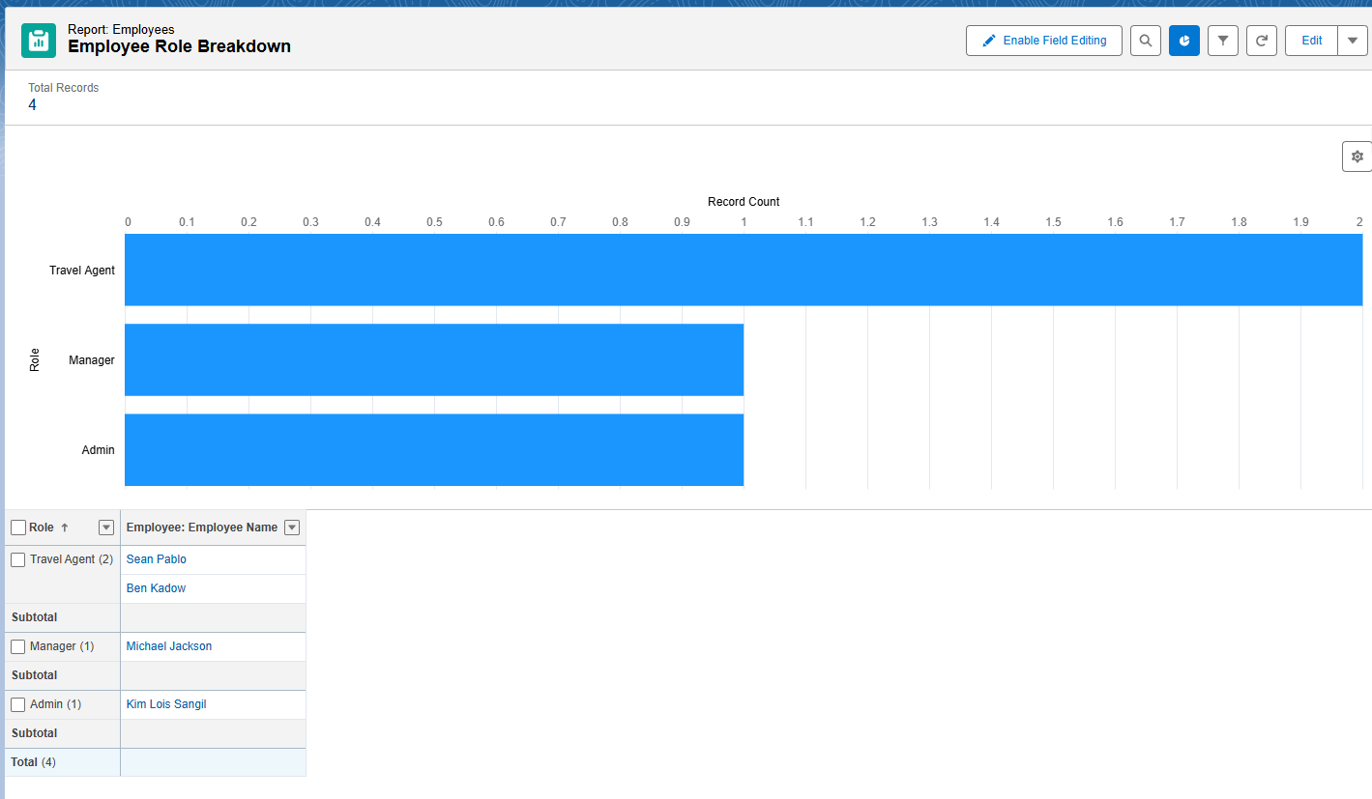

## **Milestone 18: Dashboards**

### *Activity 1: Create Dashboard*

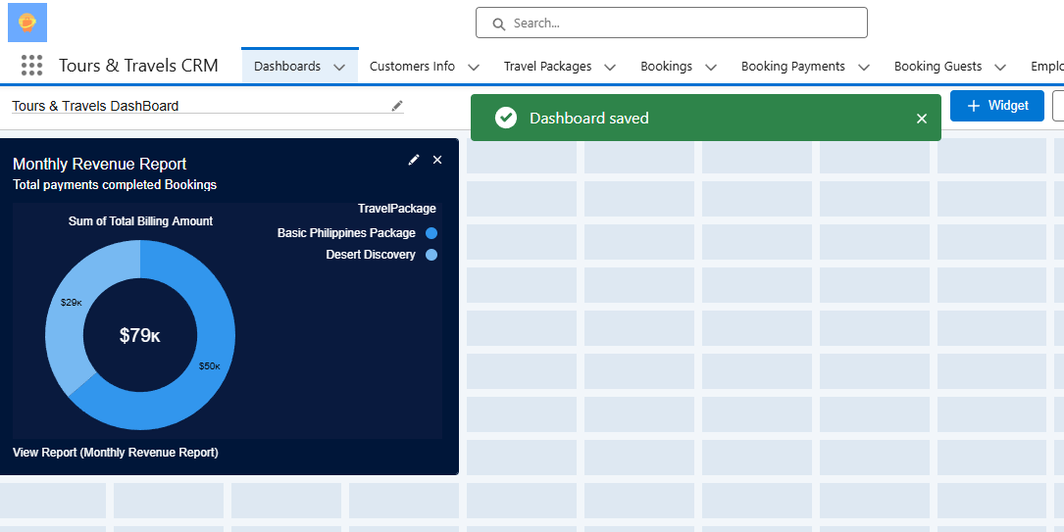

### *Activity 2: Add other Components in the Dashboard*

### *Activity 3: View Dashboard*

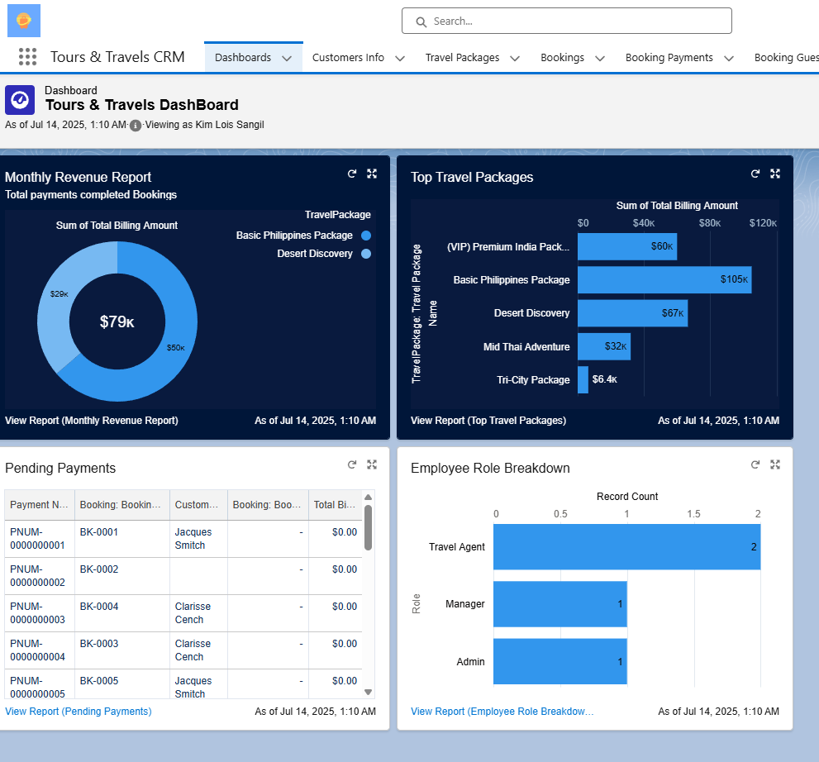

### *Activity 4: Create another 2 Dashboards*

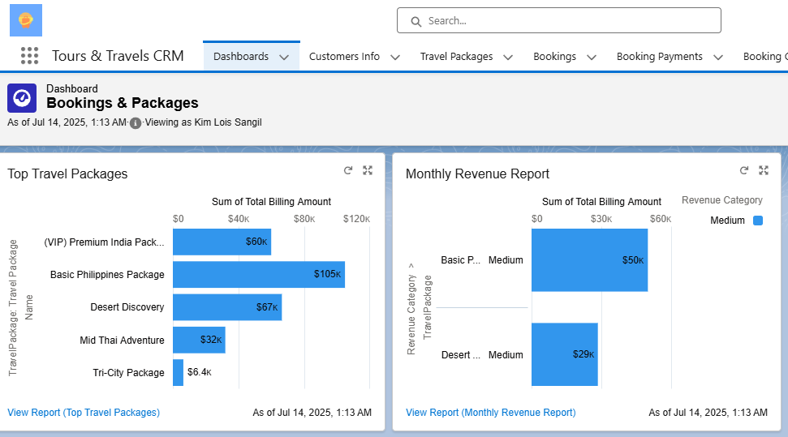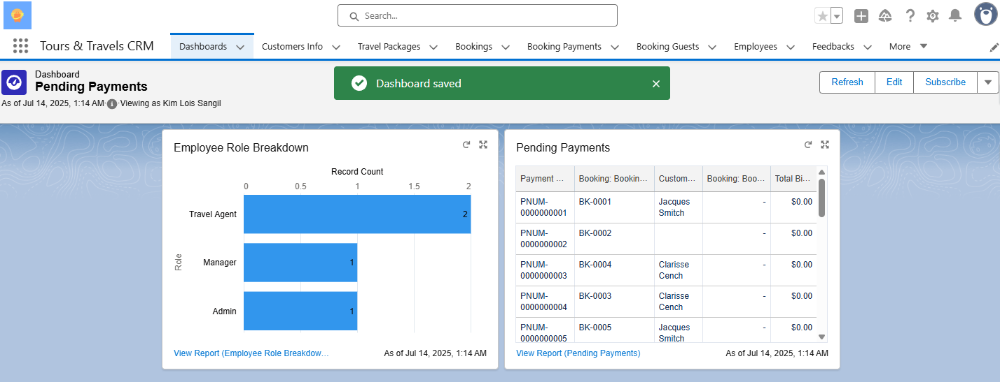

## **Milestone 19: Lightning Web Component Creation**

### *Activity 1: Create Lightning Web Component Creation*

***Deployment Success Terminal:***

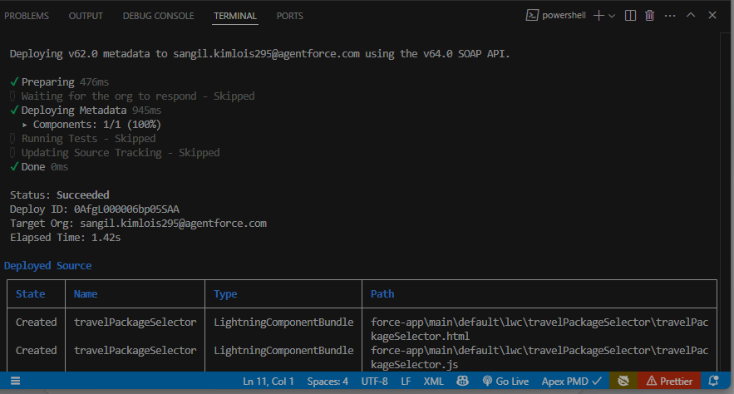

***travelPackageSelector.html:***

<template>

<lightning-card title="Travel Packages">

<div class="slds-p-around_medium">

<lightning-combobox

name="country"

label="Select Country"

value={selectedCountry}

placeholder="Choose a country"

options={countryOptions}

onchange={handleCountryChange}>

</lightning-combobox>

<template if:true={packages}>

<template for:each={packages} for:item="pkg">

<div key={pkg.Id} class="slds-box slds-m-top_small">

<p><b>Package Name:</b> {pkg.Name}</p>

<p><b>Package Type:</b> {pkg.Package_Type__c}</p>

<p><b>Duration in Days:</b> {pkg.Duration_in_Days__c}</p>

<p><b>Guide Facility:</b> {pkg.Guide_Included__c}</p>

<p><b>Places Covered:</b> {pkg.Places_Covered__c}</p>

<p><b>Membership:</b> {pkg.Membership__c}</p>

<p><b>Region:</b> {pkg.Region__c}</p>

<p><b>Transportation Mode:</b> {pkg.Transportation_Modes__c}</p>

<p><b>Availability Status:</b> {pkg.Availability_Status__c}</p>

<p><b>Average Rating:</b> {pkg.Average_Rating__c}</p>

</div>

</template>

</template>

<template if:true={error}>

<p class="slds-text-color_error">{error}</p>

</template>

</div>

</lightning-card>

</template>

[***travelPackageSelector.js***](http://travelpackageselector.js)***:***

import { LightningElement, track } from 'lwc';

import getPackagesByCountry from '@salesforce/apex/TravelPackageController.getPackagesByCountry';

export default class TravelPackageSelector extends LightningElement {

@track selectedCountry = '';

@track packages = [];

@track error;

get countryOptions() {

return [

{ label: 'India', value: 'India' },

{ label: 'France', value: 'France' },

{ label: 'Philippines', value: 'Philippines' },

{ label: 'USA', value: 'USA' },

{ label: 'Saudi Arabia', value: 'Saudi Arabia' },

{ label: 'Switzerland', value: 'Switzerland' },

{ label: 'Thailand', value: 'Thailand' },

{ label: 'Maldives', value: 'Maldives' },

{ label: 'Dubai', value: 'Dubai' },

{ label: 'Sri Lanka', value: 'Sri Lanka' },

{ label: 'Bangkok', value: 'Bangkok' },

{ label: 'Singapore', value: 'Singapore' },

{ label: 'Myanmar', value: 'Myanmar' },

{ label: 'Nepal', value: 'Nepal' }

];

}

handleCountryChange(event) {

this.selectedCountry = event.detail.value;

this.packages = [];

this.error = undefined;

getPackagesByCountry({ country: this.selectedCountry })

.then(result => {

this.packages = result;

})

.catch(error => {

this.error = error.body.message;

});

}

}

[***travelPackageSelector.js***](http://travelpackageselector.js)***:***

***<?xml version="1.0" encoding="UTF-8"?>***

***<LightningComponentBundle xmlns="http://soap.sforce.com/2006/04/metadata">***

***<apiVersion>62.0</apiVersion>***

***<isExposed>true</isExposed>***

***<targets>***

***<target>lightning__AppPage</target>***

***<target>lightning__HomePage</target>***

***<target>lightning__RecordPage</target>***

***</targets>***

***</LightningComponentBundle>***

## **Milestone 20: Lightning App Page Creation**

### *Activity 1: Adding the Lightning Component to the App Page*

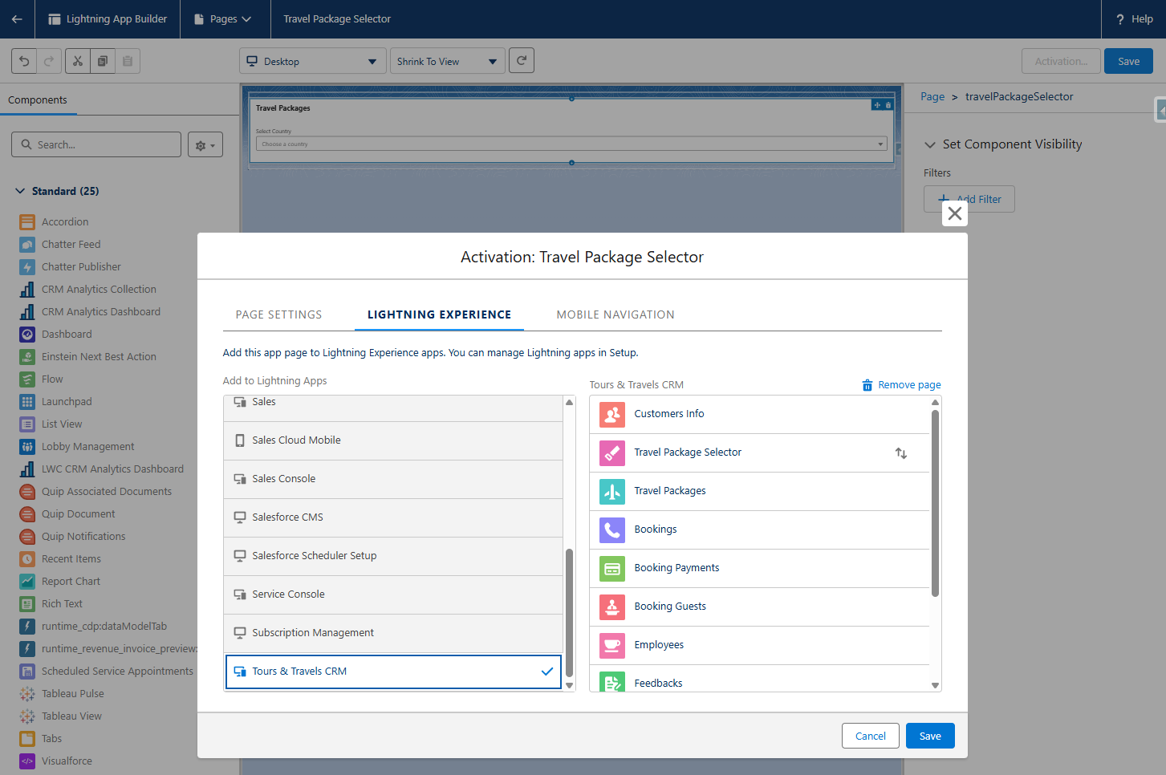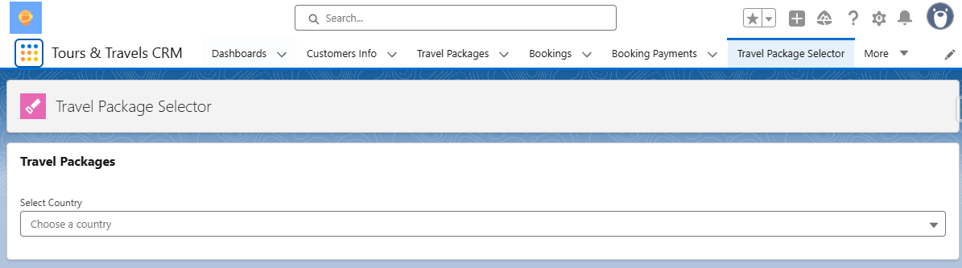

Phase 4: Data Migration, Testing & Security

## **Milestone 21: Duplicate and Matching rules**

### *Activity 1: Create Field History Tracking on Tours & Travels CRM objects on certain fields to track and show the field history in the History related list of an object*

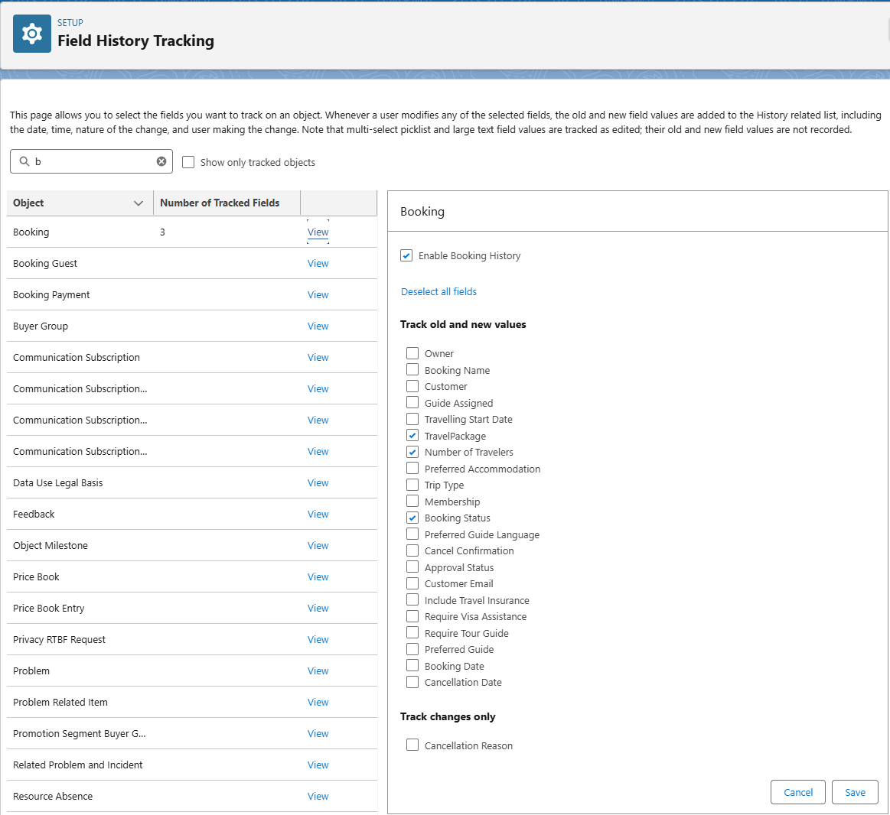

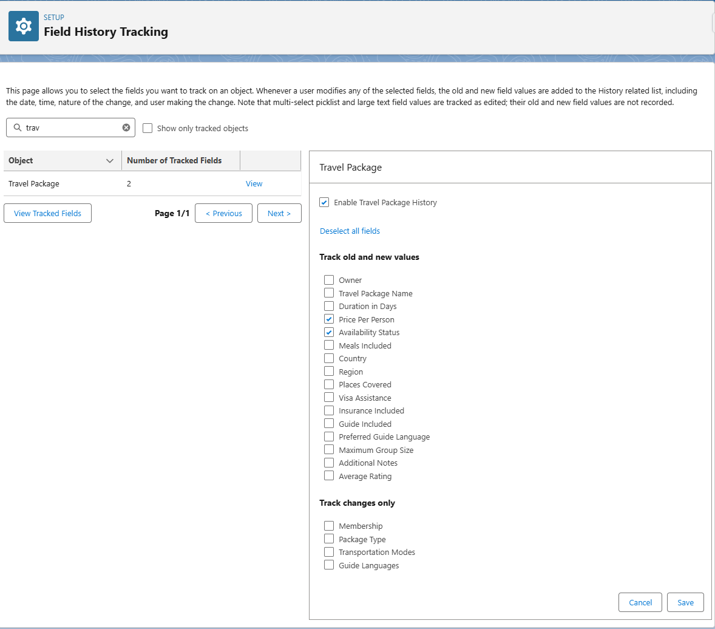

## **Milestone 22: Duplicate and Matching rules**

### *Activity 1: Create a Custom Matching Rule*

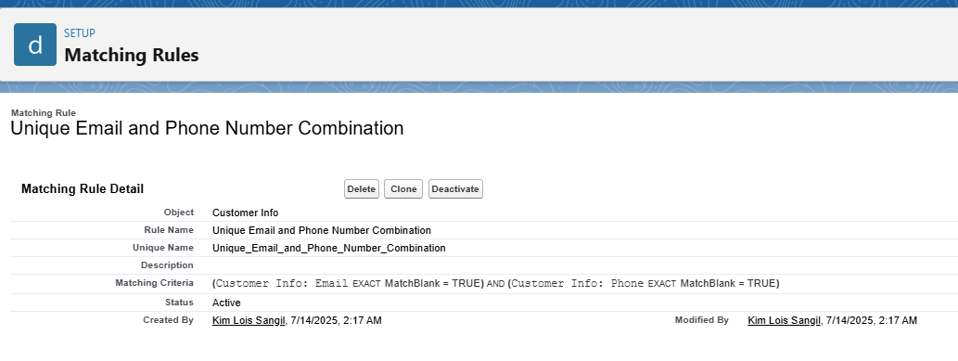

### *Activity 2: Create a Duplicate Rule*

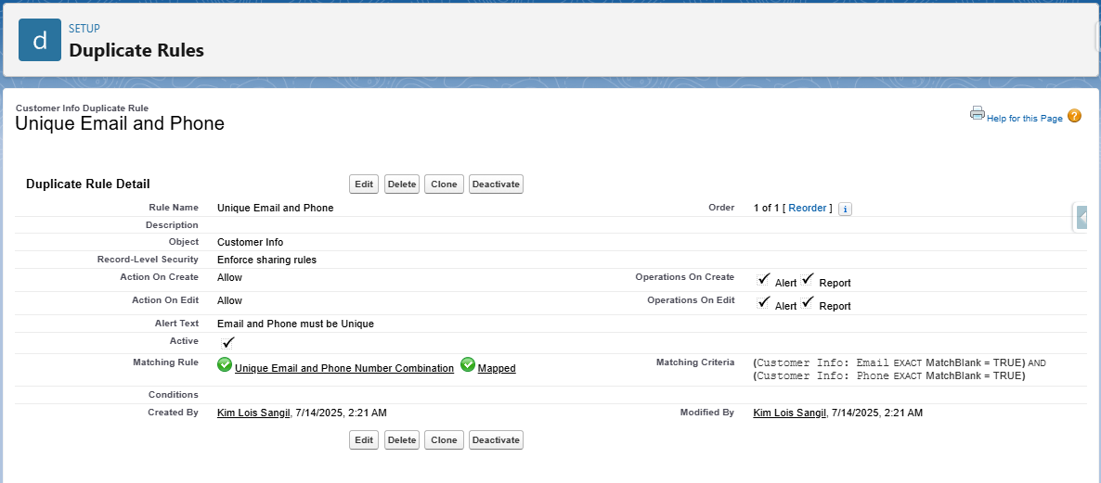

## **Milestone 23: Profiles**

### *Activity 1: Travel Agent Profile Creation*

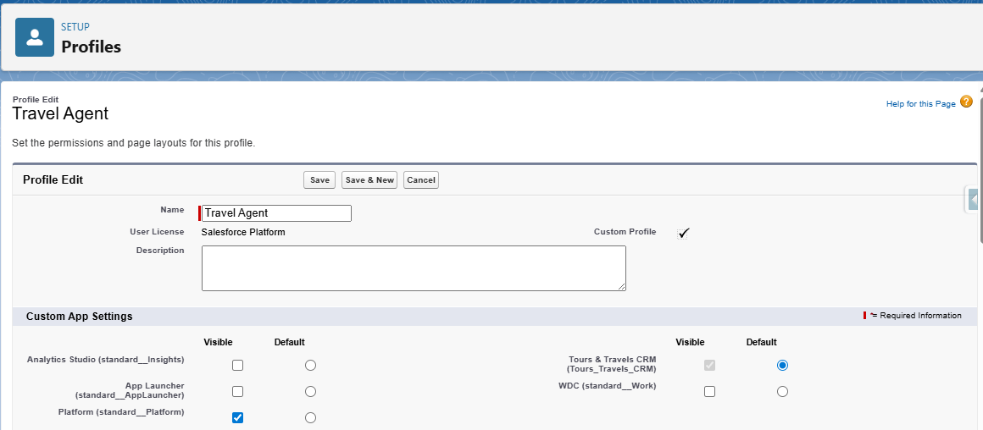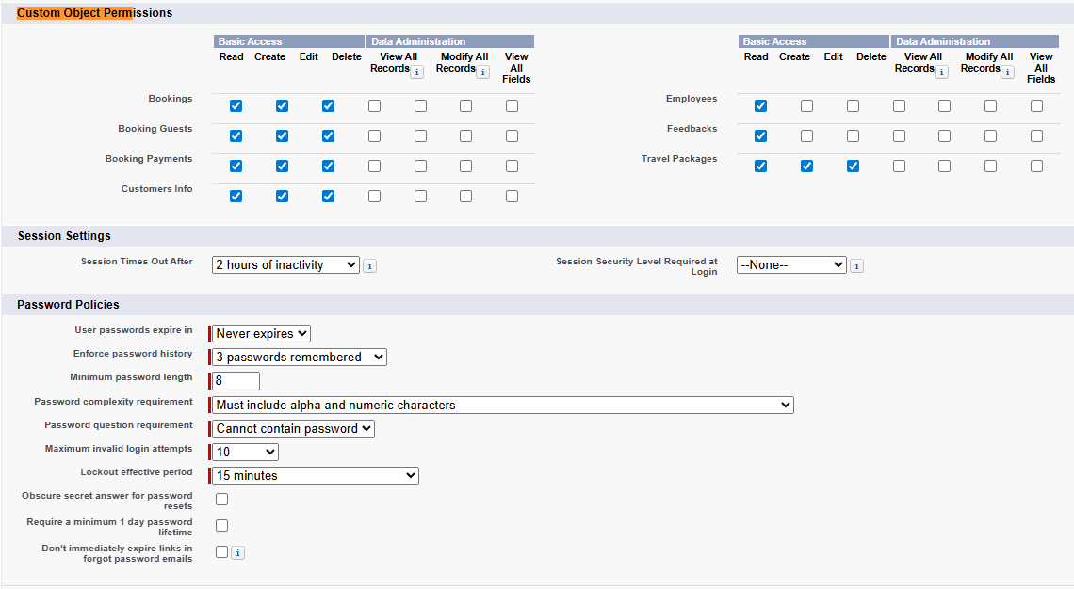

### *Activity 2: Tour Guide Profile Creation*

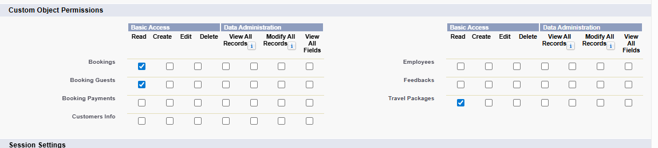

### *Activity 3: Finance Officer Profile Creation*

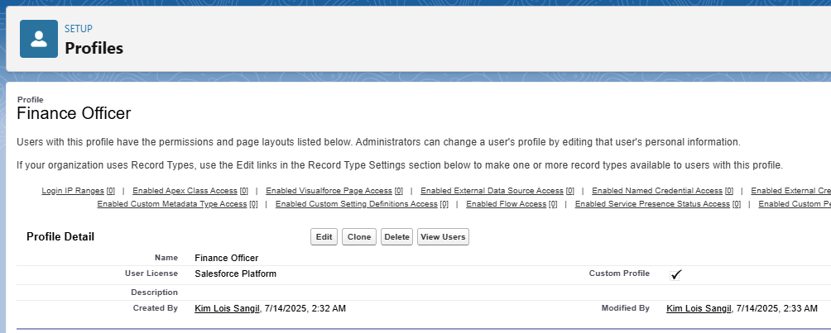

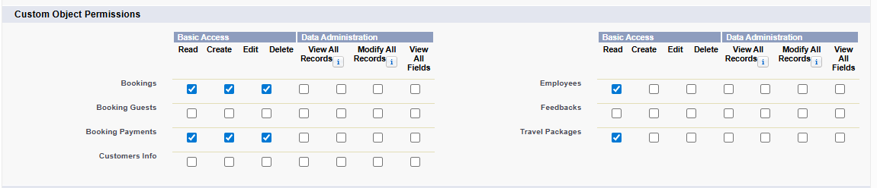

### *Activity 4: Marketing Executive Profile Creation*

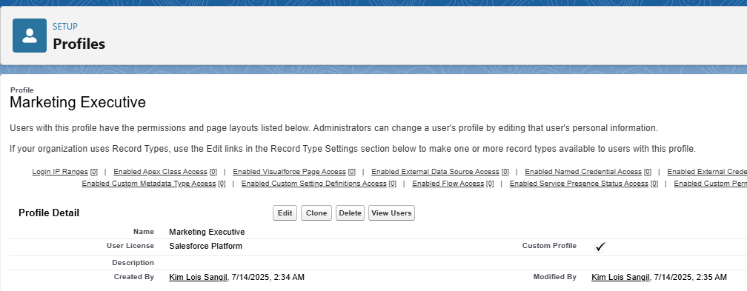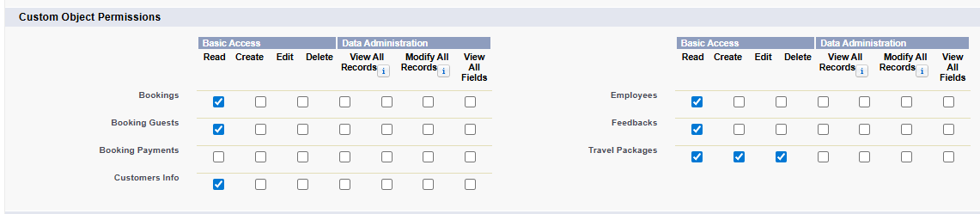

### *Activity 5: Customer Service Rep Profile Creation*

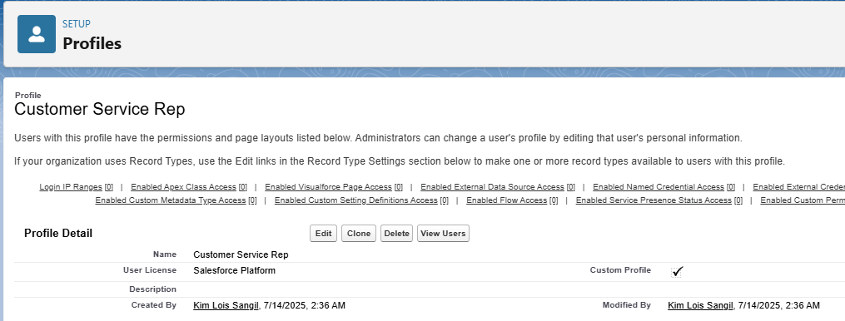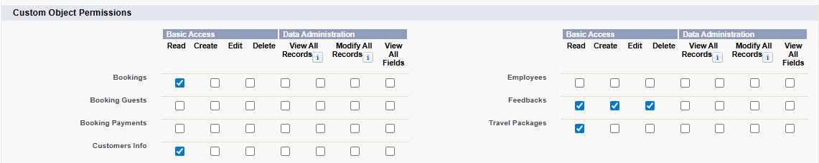

## **Milestone 24: Roles & Role Hierarchy**

### *Activity 1: Creation of Travel Agent Manager Role*

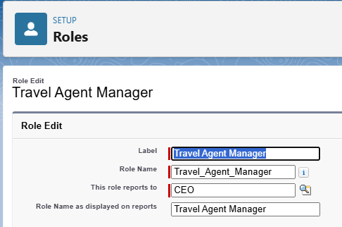

### *Activity 2: Creation other Roles Under Travel Agent Manager Role*

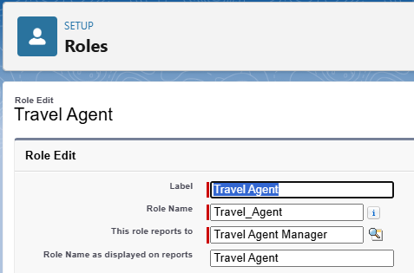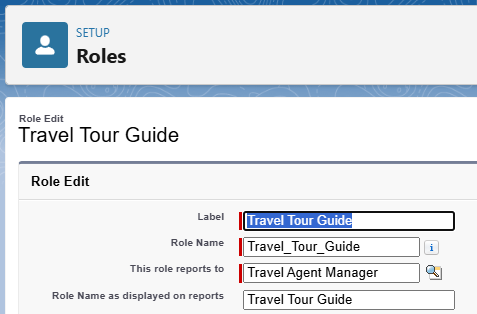

### *Activity 3: Creation other Three Roles Under CEO Role*

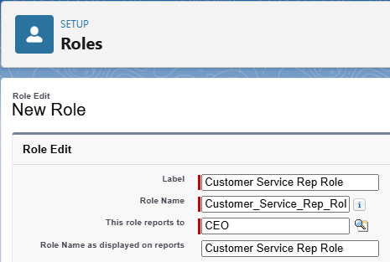

## **Milestone 25: Permission Set**

### *Activity 1: Creating New Permission Set*

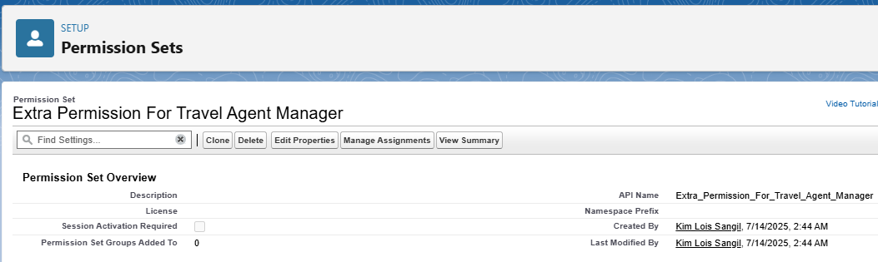

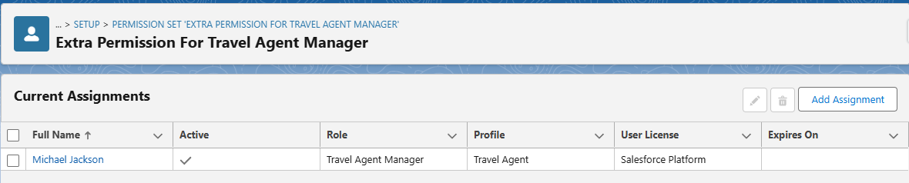

## **Milestone 26: Permission Set**

### *Activity 1: Creating Sharing Rule*

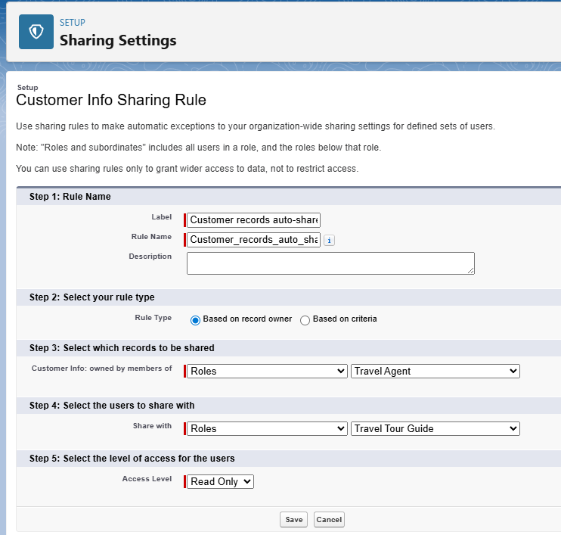

## **Milestone 27: Test Classes**

### *Activity 1: Creation of a Test Class*

I was able to encounter 2 errors in this activity due to Places_Covered__c and Booking_Date__c missing from the code itself so I added two lines of code to the given in the instructions which resulted to the test succeeding and the two lines of code i added were:  
**Places_Covered__c = 'Rome, Paris, Madrid'**

**Booking_Date__c = Date.today(),**

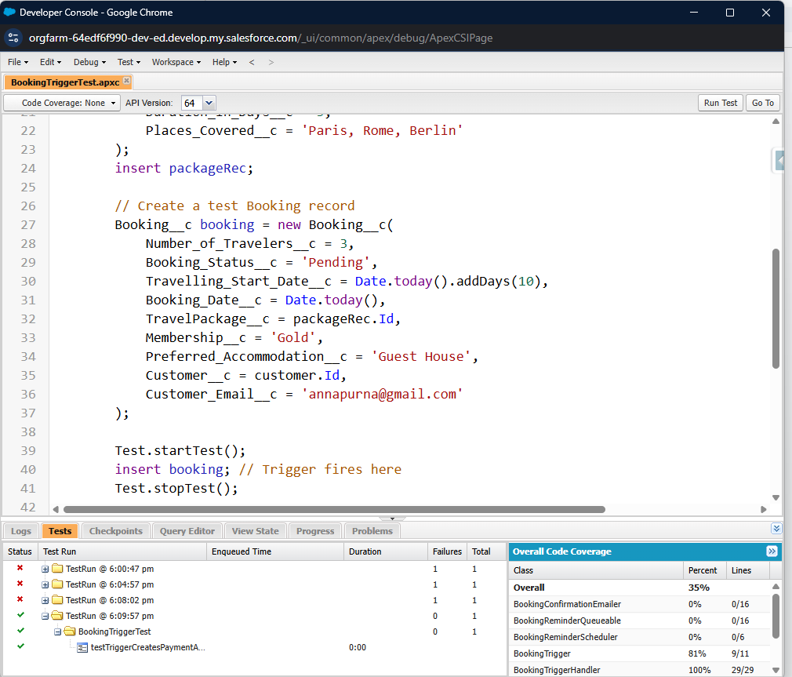

## **Milestone 28: Preparing Test Cases & Fixing Defects**

### *Activity 1: Test Case 1: Customer Creation*

While accomplishing this activity, I also noticed that I needed to fix the field dependencies of the city>country fields within the ‘Customer Info’ object, which I did, and also I have deleted other countries that did not seem to be countries (see screenshots below for steps taken)

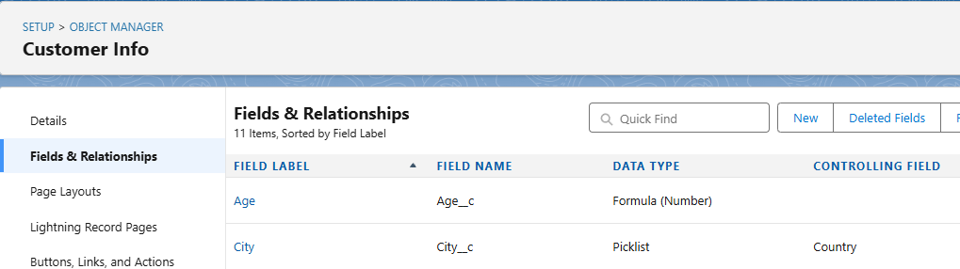

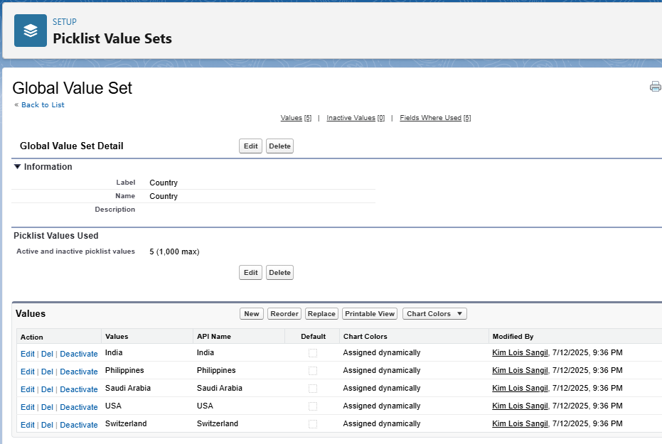

**Confirmed that dependencies were fixed as city is greyed out before selecting a country:**

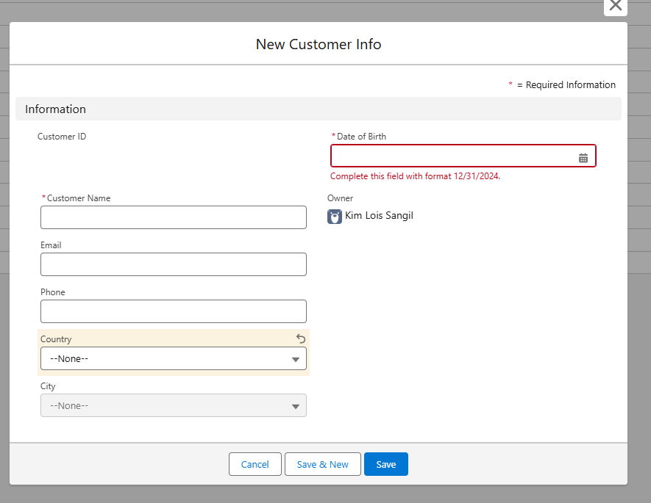

**The proper countries are now showing up:**

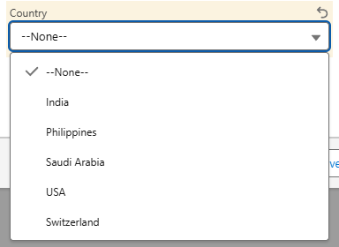

Also fixed that applicable cities are only going to show up to applicable countries:

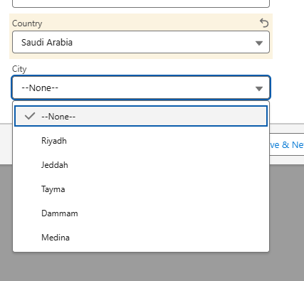

**New Customer with populated fields (pre-save):**

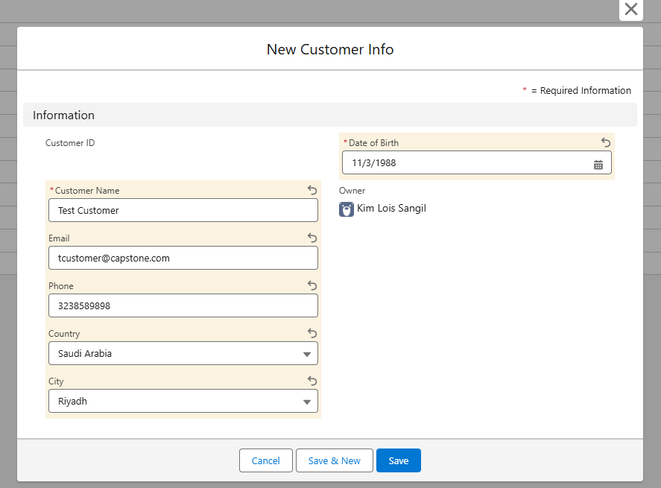

**New Customer with populated fields (post-save):**

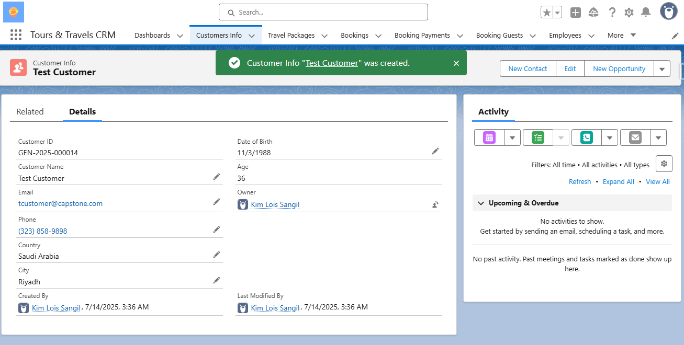

**New Customer in Customer Info tab/list:**

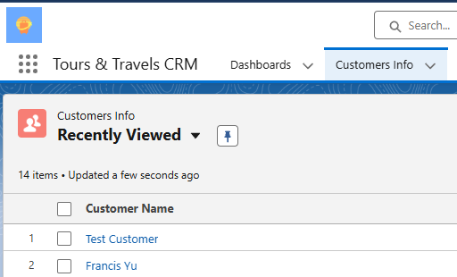

### *Activity 2: Test Case 2: Booking Creation*

While creating the booking, I was able to create the booking itself but I found out that it does not automatically create a name for the ‘Booking Payment’ record.

So I created a flow to automatically have it named ‘Customer’s Name’ - ‘TravelPackage’ ‘DateCreated’ to better help finance employees keep track of new booking payments created.

**Get Booking:**

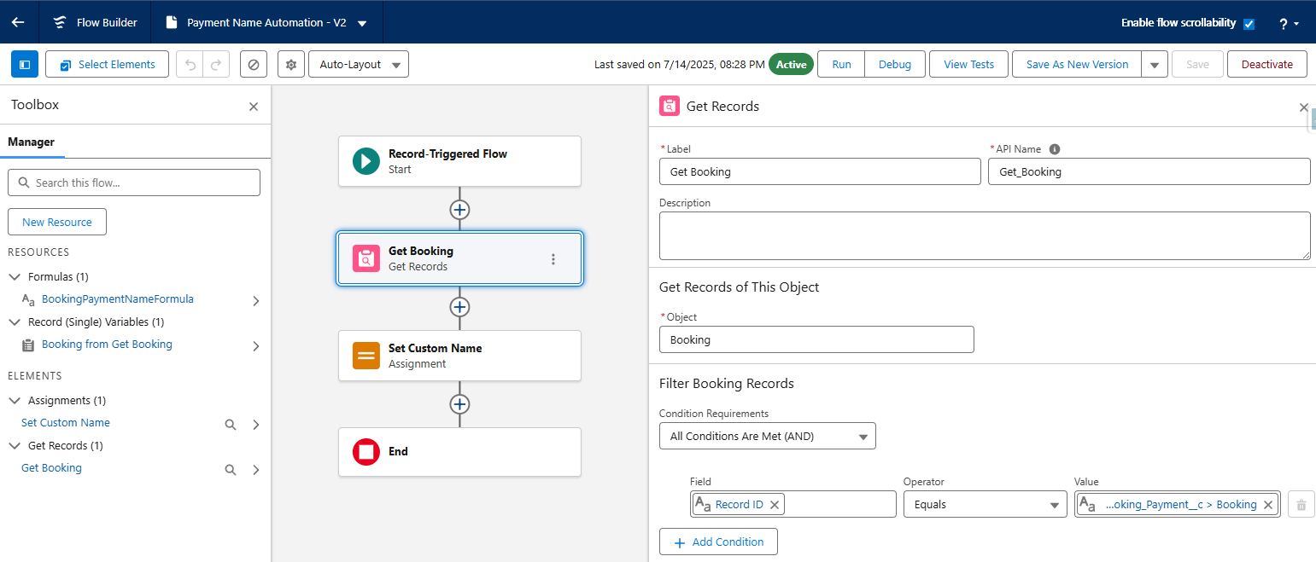

**Name Assignment:**

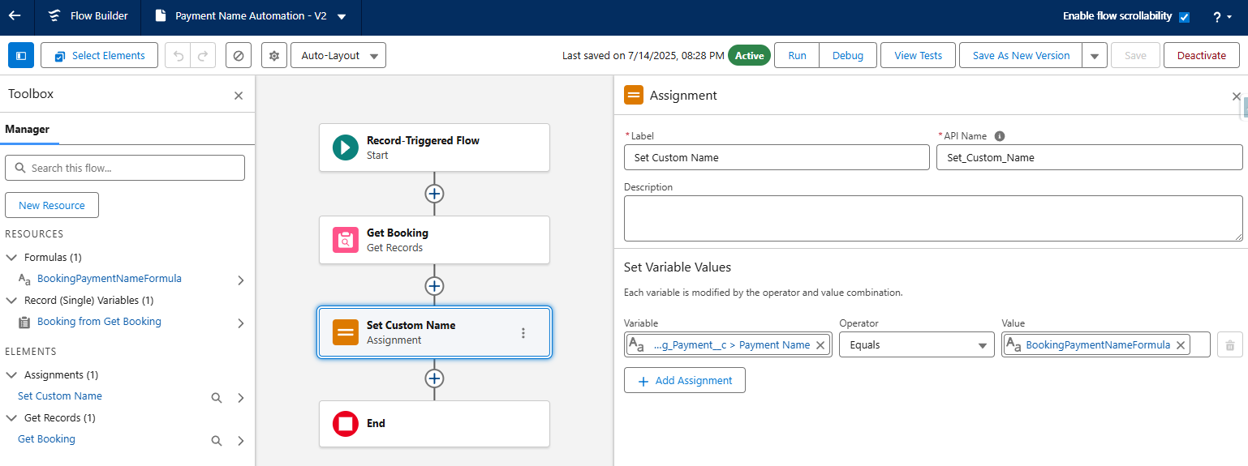

**BookPaymentName Formula:**

*{!Get_Booking.Customer__r.Name} & " - " &*

*{!Get_Booking.TravelPackage__r.Name} & " " &*

*TEXT(MONTH(TODAY())) & "/" &*

*TEXT(DAY(TODAY())) & "/" &*

*RIGHT(TEXT(YEAR(TODAY())), 2)*

**Booking Created (Saved Successfully):**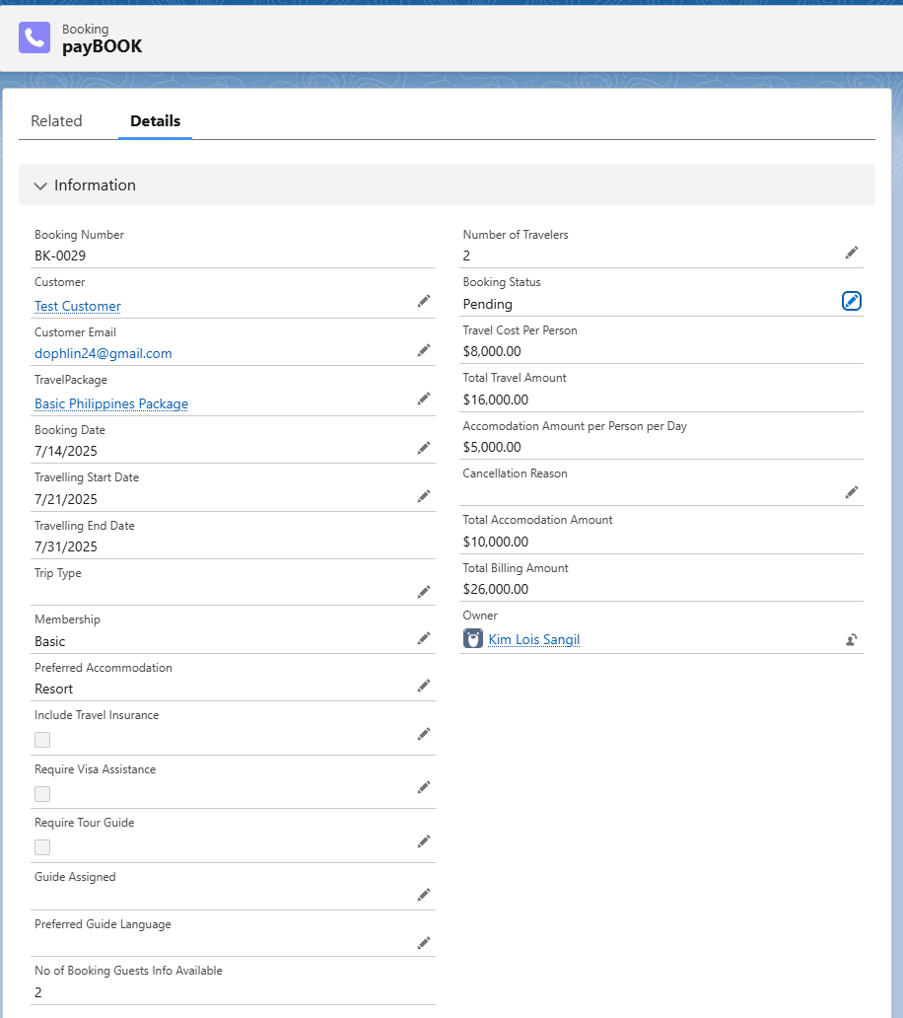

**Bookings List page:**

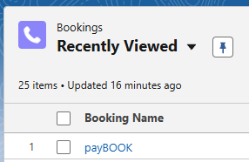

**Booking Payment Result (Automated Successfully):**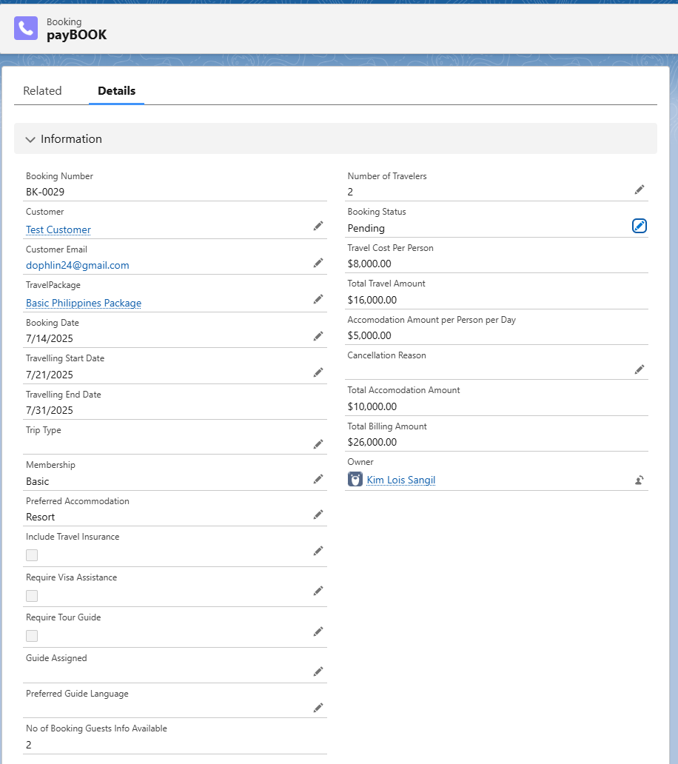

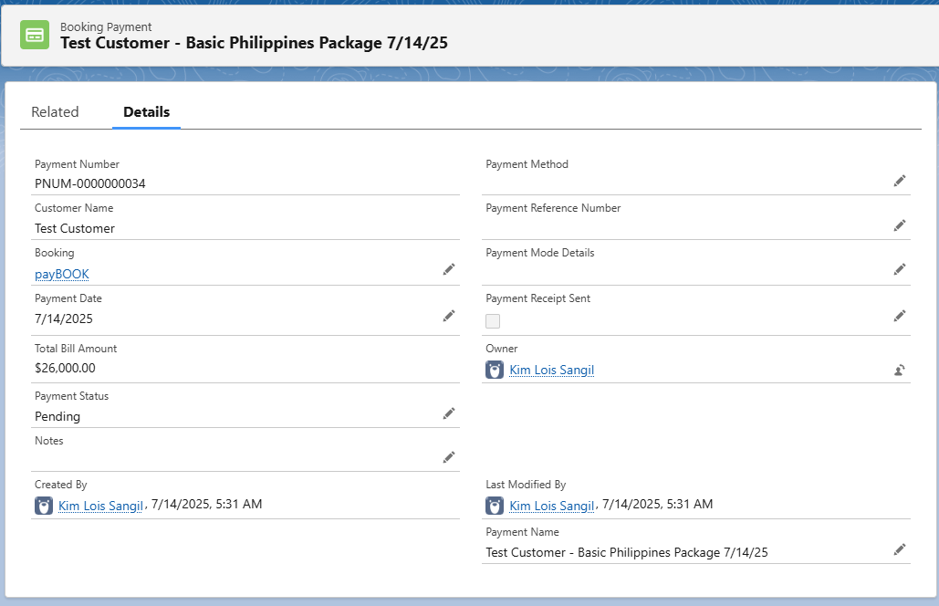

**Booking Guests Records (Automated Successfully):**

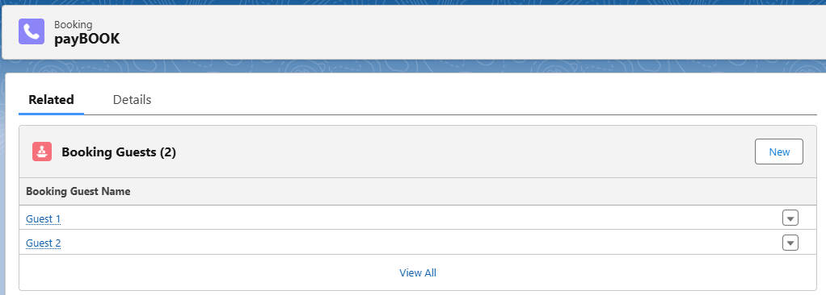

### *Activity 3: Test Case 3: Payment Status Update & Email Notification*

**Booking Payment Completed:**

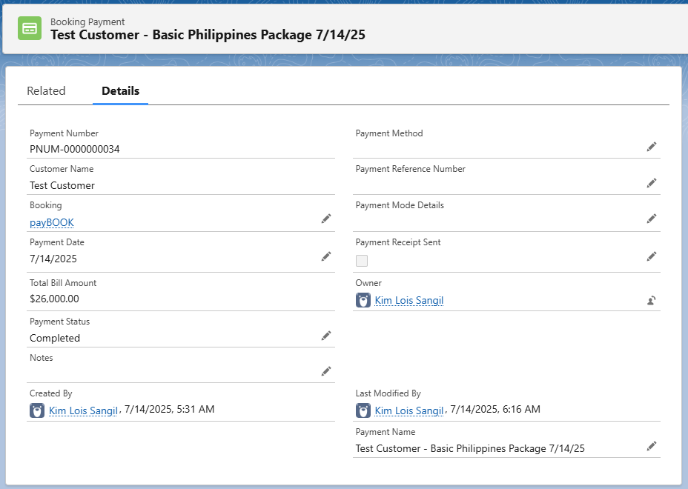

**Booking Status Automatically Confirmed:**

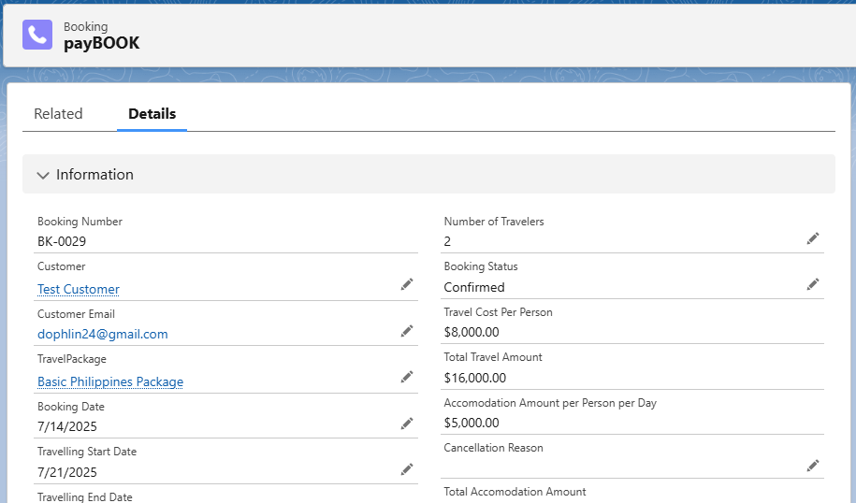

**Email Received:**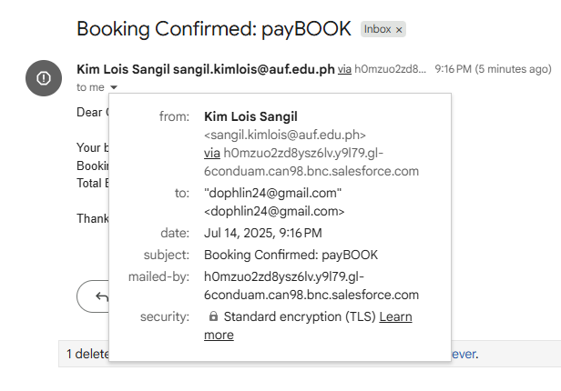

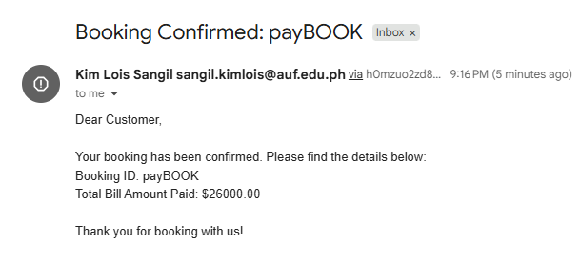

### *Activity 4: Other Test Cases*

#### TEST CASE 1: *Booking Creation > Booking Payments Automation*

**Purpose:** Users should be able to create ‘Bookings’ without having to create ‘Booking Payments’ for the created booking.

**Input Data:**

Customer: Luis Manalo

Email: [Dophlin24@gmail.com](mailto:Dophlin24@gmail.com)

TravelPackage: (VIP) Premium India Package

Booking Date: 7/14/25

Travelling Start Date: 7/16/25

Membership: VIP

Preferred Accomodation: Luxury Hotel

Number of Travelers: 6

Booking Status: Pending

Booking Name: LManalo - Test Case 1

**Steps to Execute:**

1. Go to the ‘Booking’ tab (Travels&ToursCRM) > New
2. Fill all required fields
3. Save
4. Go to the ‘Booking Payments’ tab
5. Verify if ‘Booking Payments’ record has automatically been processed.

**Expected Outputs:**

* Created ‘Booking’ information carries over to ‘Booking Payments’

**Actual Result:**

* ‘Booking’ processed carried over to ‘Booking Payments’ successfully

**Status:**

Pass

**Remarks:**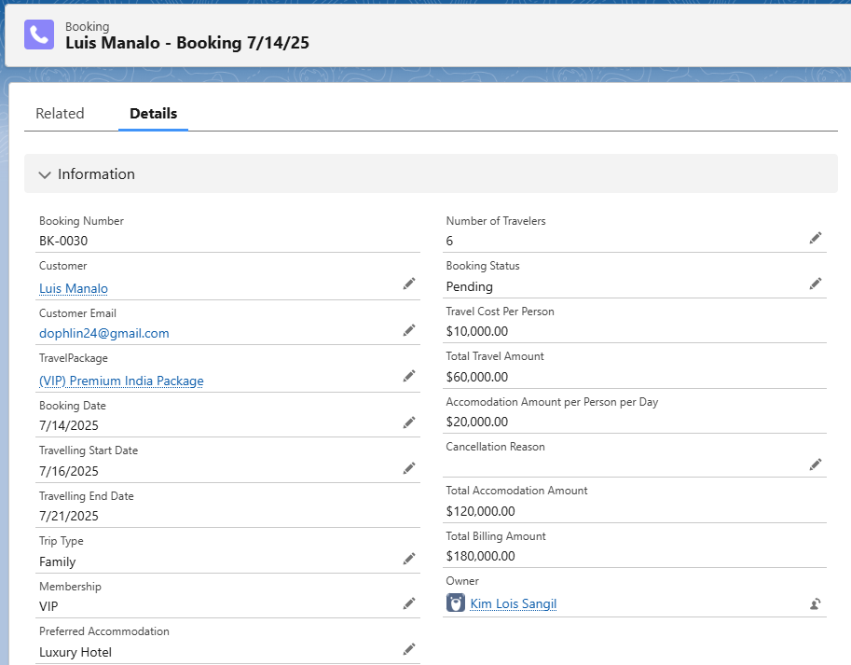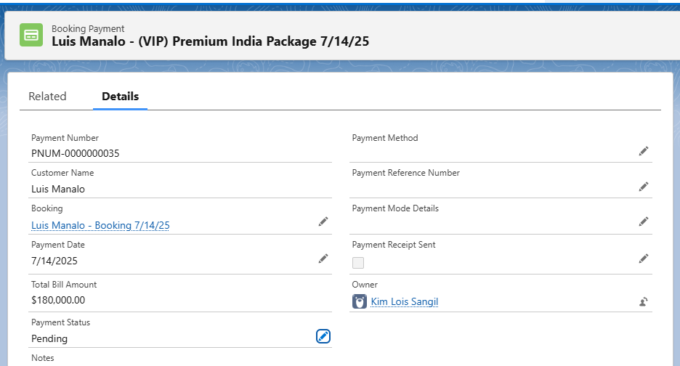

#### TEST CASE 2: Trip Cancellation with Reason Capture & Approval

**Purpose:** Cancellation of bookings should trigger the approval process of the booking cancellation being requested to the immediate manager. Also, the immediate manager should be able to see the booking in the ‘Items to Approve’ tab. The approved cancellation should also reflect in the booking’s ‘Related’ tab.

I have also added a new flow here for the ‘Booking Name’ to be added with (CANCELLED) if the approval was pushed through by the manager for better visibility.

**Input Data:**Customer: Sofia Reyes  
Email: dophlin24@gmail.com  
TravelPackage: Basic Philippines Package  
Booking Date: 7/15/25  
Travelling Start Date: 7/25/25  
Membership: Basic  
Number of Travelers: 2

Preferred Accommodation: Resort

Booking Name: SReyes - Test Case 2

Cancellation Date: 7/14/25  
Cancellation Reason: “Family Emergency”

**Steps to Execute:**

1. Login in a ‘Travel Agent’ Account
2. Go to the ‘Booking’ tab > New
3. Fill in the required fields
4. Save the booking
5. Open the newly created booking
6. Click Edit
7. Enter a cancellation reason in Cancellation Reason
8. Set Cancel Confirmation checkbox to true
9. Save the record and submit for approval
10. Log in as approver > Go to Approvals > Approve the cancellation
11. Confirm that Approval Status = Approve

**Expected Outputs:**

* Booking is saved successfully
* Cancellation reason and date are captured
* Approval process is triggered
* Once approved, Approval Status is updated

**Actual Result:**Cancellation approval was not working, so I edited the approval process due to the approver being assigned as me/admin so I changed it to the immediate manager of the submitter.

After the cancellation was approved, it just changed to ‘Pending’ instead of ‘Closed’, so I changed the ‘Intial Submission Actions’ in the ‘Approval Process’ page and changed it to set booking status to ‘Closed’ post-approval.

I have also added a flow wherein if a booking’s cancellation has been approved, as soon as the booking status changes to ‘Closed’ it will add (CANCELLED) to its ‘Booking Name’ for better visibility.

**Status:**Pass

**Remarks:**Ensure all approvers are set up in the Approval Process in case of future issues.

**(Travel Agent Account) Booking Created:**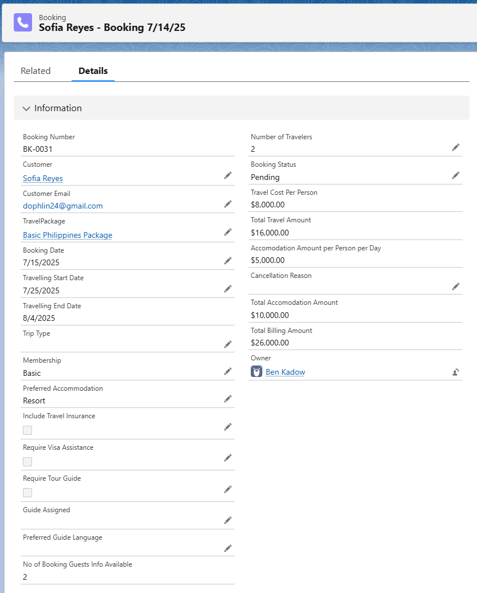

**(Travel Agent Account) Cancellation In Booking:**

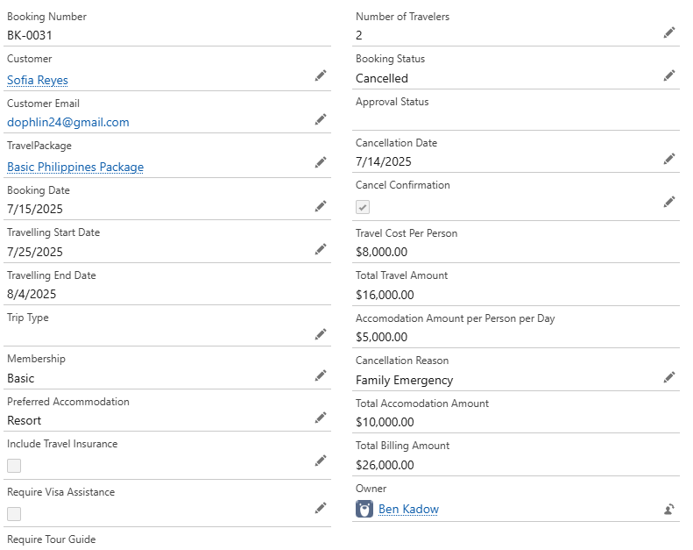

**(Travel Agent Manager Account) Cancellation Approval:**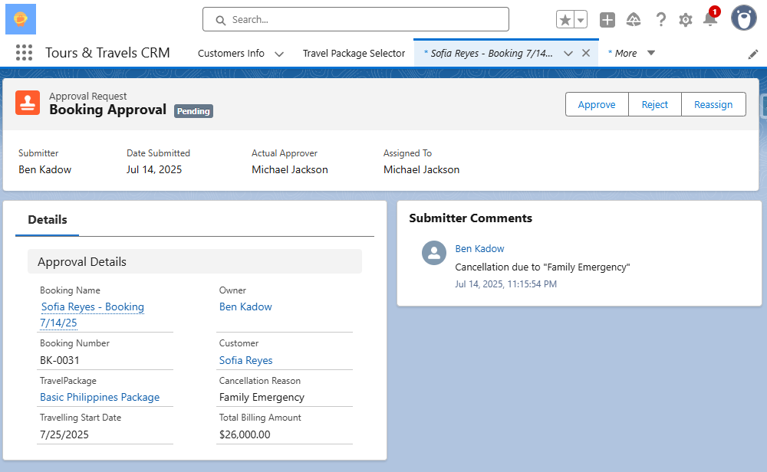

**(Travel Agent Manager Account) Cancellation Approved:**

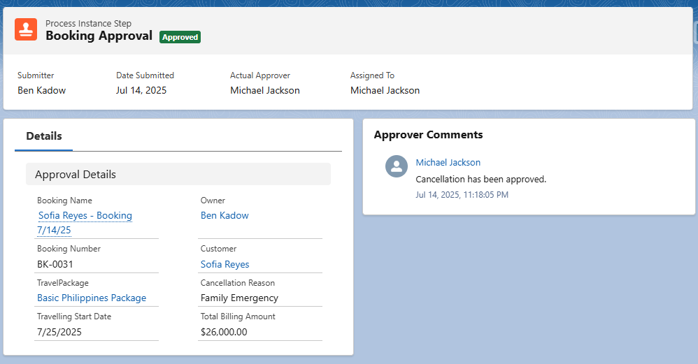

**Approval History:**

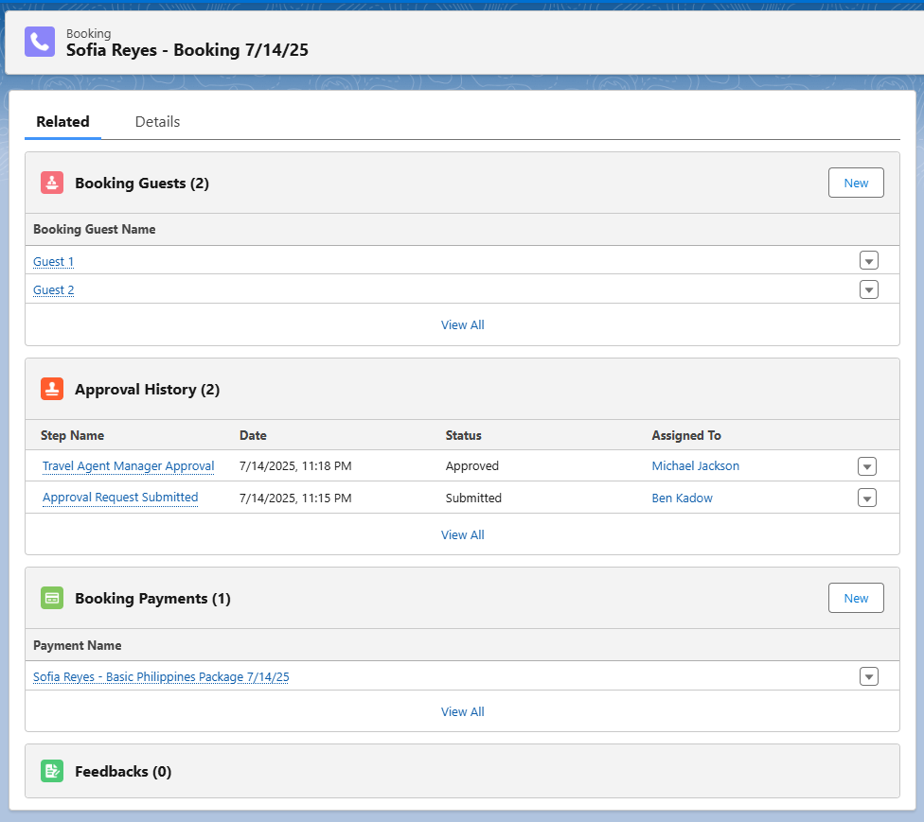

**Booking status changed to ‘Closed’ after approval:**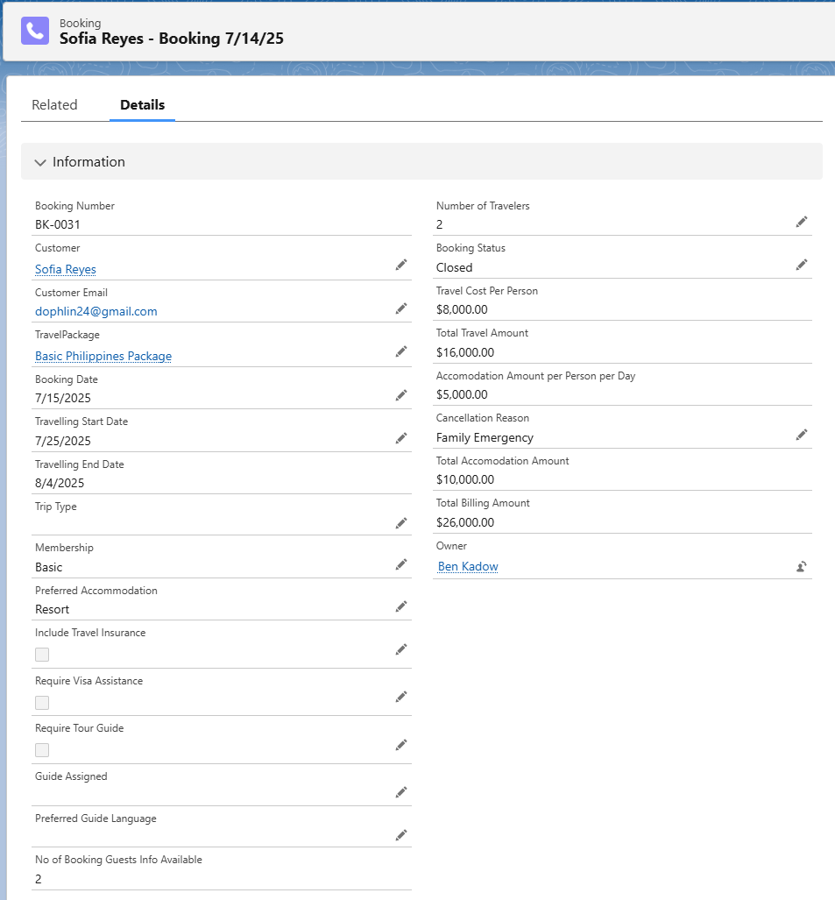

**Booking Name Check Cancellation Formula:**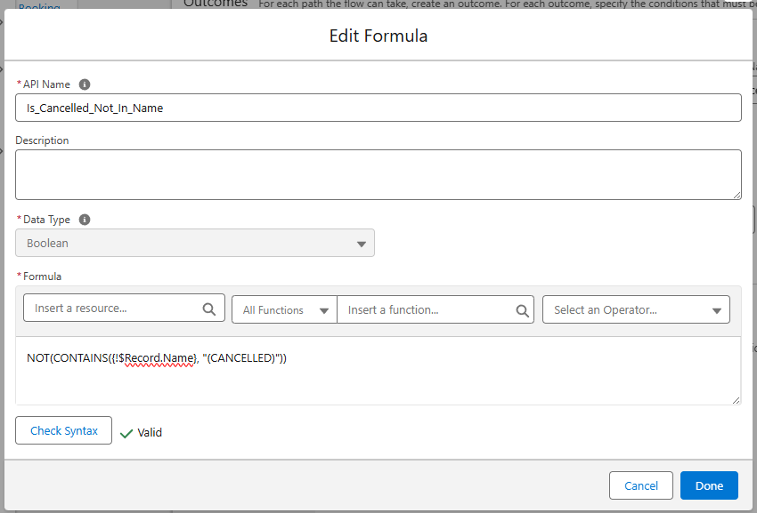

**Changing Booking Name Cancellation Formula:**

*IF(*

*AND(*

*TEXT({!$Record.Booking_Status__c}) = "Closed",*

*NOT(CONTAINS({!$Record.Name}, "(CANCELLED)"))*

*),*

*"(CANCELLED) " & {!$Record.Name},*

*{!$Record.Name}*

*)*

**Booking Name Cancellation Flow:**

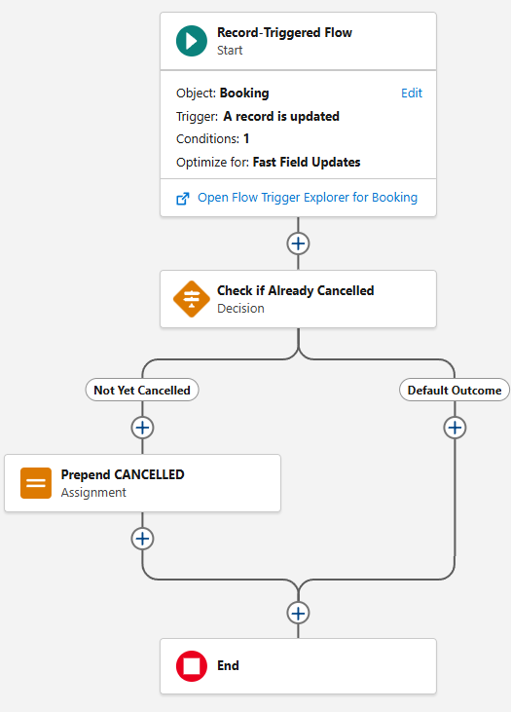

**Result of new cancellation flow:**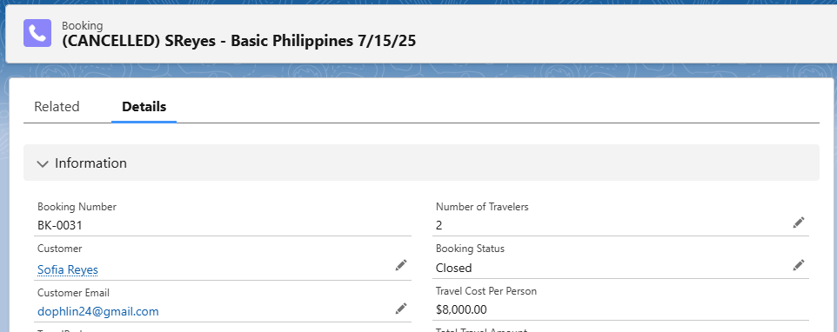

#### TEST CASE 3: Booking Payment Confirmation Automation

**Purpose:** If ‘Booking Payment’ status has been changed to ‘Complete’ it should change the ‘Booking Status’ as ‘Confirmed’ and send the customer an email confirmation.

**Input Data:**Change ‘Booking Payment’ status from ‘Pending’ to ‘Complete’

**Steps to Execute:**

1. Log in as any user with Booking creation access
2. Go to Booking Tab > Click new
3. Fill in all required fields.
4. Set ‘Booking Date’ after the ‘Travelling Start Date’ (intentionally violating the rule)
5. Click Save
6. Error message should be displayed

**Expected Outputs:**

* Error message should be displayed that rule has been validated

**Actual Result:  
1st try** Did not work the first time due to no validation rule of this exists.

**2nd try** Fully activated and worked properly as intended after creating validation rule.

**Status:**Pass

**Remarks:  
Created Validation Rule:**

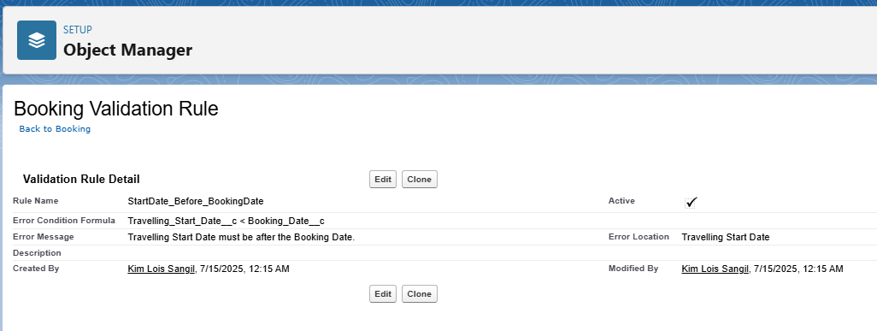

**Error message while creating the booking:**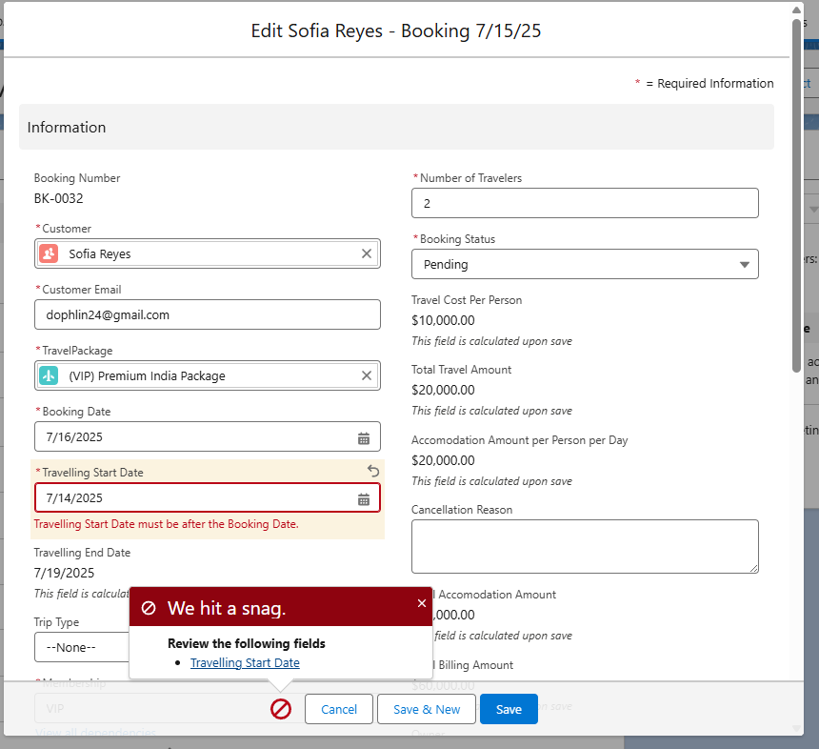

#### TEST CASE 4: Booking Payment Completion Automate

**Purpose:** To prevent manually changing a booking’s status when a payment has been completed by a customer.

**Input Data:**Change ‘Booking Payments’ status from ‘Pending’ to ‘Complete’

**Steps to Execute:**

1. Go to the Booking Payments tab
2. Change ‘Booking Payments’ status from ‘Pending’ to ‘Completed’
3. Go to the Booking tab
4. Check created booking if ‘Booking Status’ has been updated to ‘Confirmed’ status
5. Check email inbox registered if automated email has been received

**Expected Outputs:**

* ‘Booking Status’ changes to ‘Confirmed’ when ‘Booking Payments’ status is ‘Completed’
* Email notification sent to the registered booking

**Actual Result:**

* After ‘Booking Payment’ status was ‘Completed’ ‘Booking Status’ was automatically changed to ‘Confirmed’
* Email notification was received to the email registered in the booking.

**Status:**Pass

**Remarks:**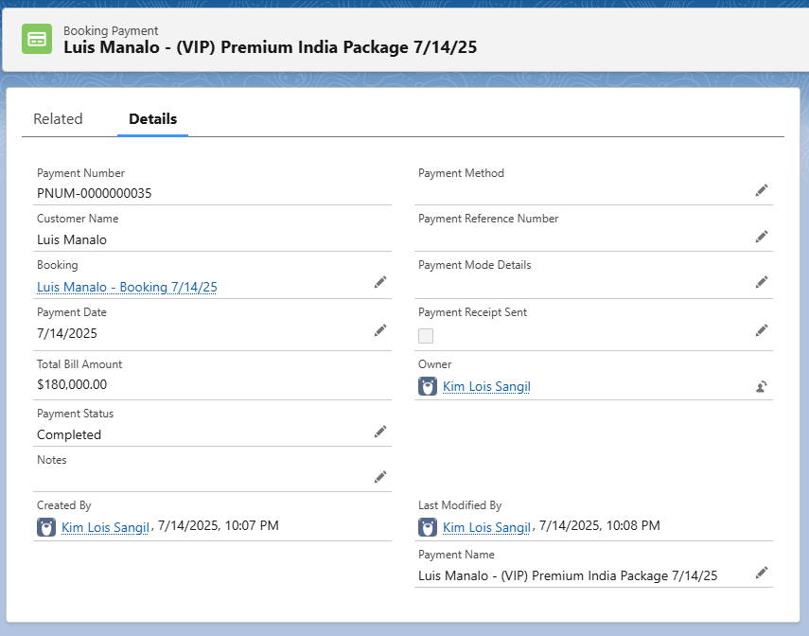

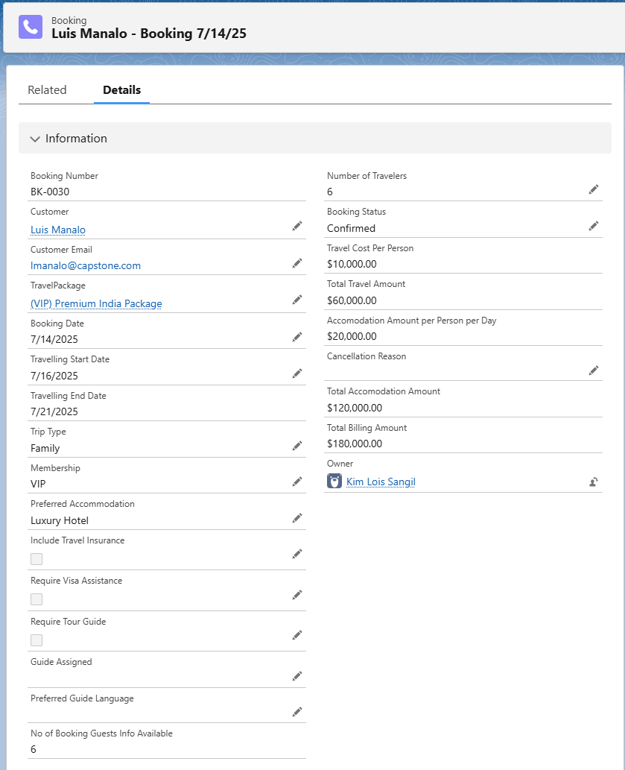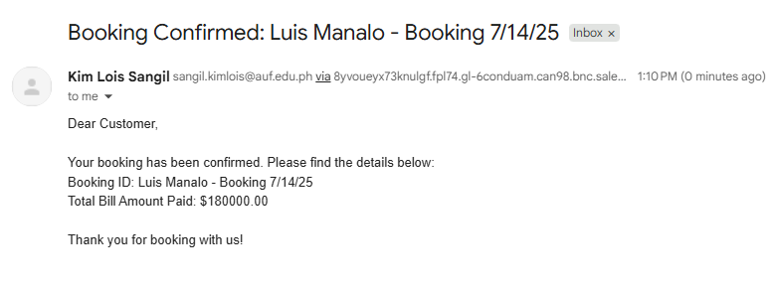

#### TEST CASE 5: Field Dependencies - Accommodation Options Based on Membership

**Purpose:** Ensuring that the applicable ‘Accommodations’ options show up to the applicable ‘Membership’ selected.

**Input Data:**Modify ‘Membership’ data and review available ‘Accommodation’ options.

**Steps to Execute:**

1. Go to Bookings tab
2. Click New to create a new booking
3. Modify ‘Membership’
4. Review available ‘Accomodation’ options

**Expected Outputs:**

* ‘Basic’ membership will offer only ‘Hotel’ & ‘Resort’ accommodations
* ‘Gold’ membership will offer only ‘Guest House’ & ‘Villa’ accommodations
* ‘VIP’ membership will offer only ‘Villa’ , ‘Cottage’ & ‘Luxury Hotel’ accommodations.

**Actual Result:**

* When selecting ‘Basic’ membership options offered are ‘Hotel’ & ‘Resort’ accommodations
* When selecting ‘Gold’ membership options offered are ‘Guest House’ & ‘Villa’ accommodations
* When selecting ‘VIP’ membership options offered are ‘Villa’ , ‘Cottage’ & ‘Luxury Hotel’ accommodations.

**Status:**Pass

**Remarks:**

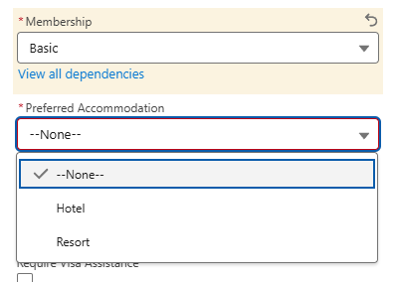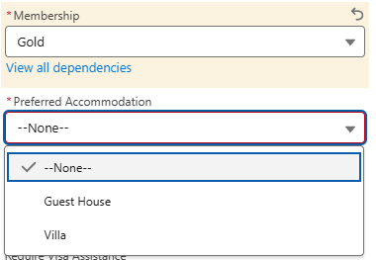

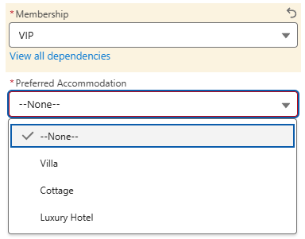

#### TEST CASE 6: Travel Package Creation & Usage

**Purpose:** Ensuring that the created ‘Travel Package’ will show as an option when creating a booking.

**Input Data:**Travel Package Name: Test Case 5 – Summer Europe Package

Country: Switzerland

Location: Europe

Duration (Days): 10

Price per Person: 2500

**Steps to Execute:**

1. Go to Travel Package tab
2. Click New to create new Travel Package
3. Fill-in required fields
4. Go to Bookings tab
5. Click new to create new booking
6. Click on ‘TravelPackage’ field
7. Verify created Travel Package can be chosen.

**Expected Outputs:**

* Created Travel Package should show as an option when creating new bookings.

**Actual Result:**

* The Travel Package created titled ‘Test Case 5 – Summer Europe Package’ showed as an option in the new booking form.

**Status:**Pass

**Remarks:**

**New Travel Packge Form:**

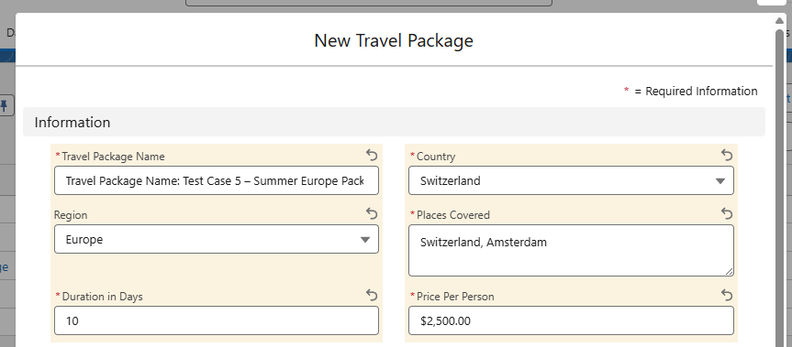

**New Booking Form with Newly Created TravelPackage:**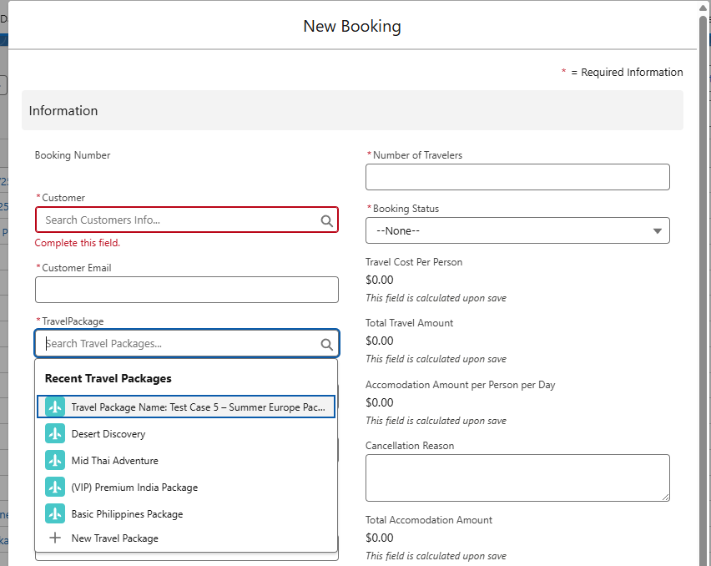

## **Milestone 29: Data Import Wizard**

### *Activity 1: Importing Records into Customer Info, TravelPackage and Employee Objects*

#### TravelPackage.csv Result Success:

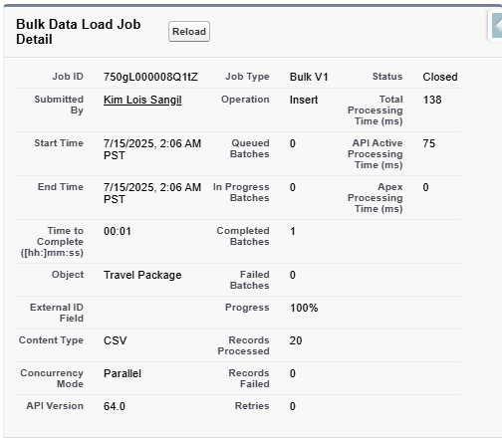

#### Customer_Info.csv Result Success:

#### Employee.csv Result Success:

Phase 5: Deployment, Documentation & Maintenance

**Deployment Strategy:**

Deployment was done directly within the Salesforce Developer Org, as the system was produced as a capstone project. In a real-world scenario, deployment should involve the use of Change Sets, ANT Migration Tool, or SFDX depending on the complexity of the changes and the environments involved.

**System Maintenance and Monitoring may include:**

* Regular review and updates of validation rules, picklist values and flows.
* Monitoring of ‘Scheduled Jobs’ and error logs through the use of Apex debug logs and flow error emails.
* Keeping roles, profiles, and permissions up-to-date and aligned with any team changes or business process updates.
* Periodic testing of automations to ensure integrity post-data imports or any field changes.

**Troubleshooting Approach:**

1. Reviewing debug logs for apex and other flow errors.
2. Testing of record creation to reproduce issues
3. Verifying if validation rules are functional when record save errors occur.
4. Isolating processes to identify what’s causing errors.
5. Documenting issues especially in test cases and developing improvements.

CONCLUSION

The capstone project for Tours and Travels CRM Application is a success, as goals and business requirements were met, core operations such as booking management, customer handling, employee coordination, and travel package management were fulfilled and fully operational. By utilizing Salesforce’s platform capabilities, namely, custom objects, flows, validation rules, approval processes, and automation; the capstone project shows how CRM can enhance the operational efficiency and data integrity of a travel-based business.

Throughout the phases of requirement gathering, system design, implementation, testing, and data migration, each individual feature was built with all knowledge acquired from the internship program.

Now, the Travels & Tours CRM is capable of:

* Handling end-to-end booking and payment workflows automatically
* Managing employee and customer records with standardized access control.
* Establishing approval processes and error prevention along with validation rules
* Providing business insights through the use of reports and dashboards.

With this project, I have not only fulfilled academic requirements, but also enforced all processes and nuances learned from discussions, modules and trailmixes. I was able to test my knowledge and further my skills while hoping to raise my chances of landing a job in fields that include developing Salesforce-based CRM for a better future and career.